Monday  Week 2 |  |  | Tuesday  Week 2 |  |  |  | Wednesday  Week 2 |  | Thursday  Week 2 |  |  |  | Friday  Week 2
Main Meal Choice
Oven Baked Crumbed Haddock  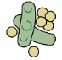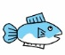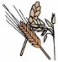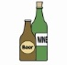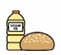  Creamed Potatoes,  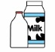  Garden Peas or Baked Beans |  |  | Lamb Moussaka  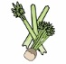  Garlic Bread  Sweetcorn or Mixed Salad |  |  |  | Sausage Roll  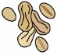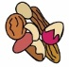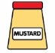  Jacket Wedges  Baked Beans or  Vegetable of the day |  | Chicken Curry  Steamed Wholegrain Vegetable Rice  OR Naan Bread  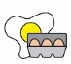 |  |  |  | Pork & Vegetable Pie  Creamed Potatoes  Country Vegetable Mix
Vegetarian Choice
(V) Vegetarian Burger  Creamed Potatoes,  Garden Peas or Baked Beans |  |  | (V) Cheese & Tomato Baguette Pizza  Mixed Salad and  Coleslaw |  |  |  | (V) Vegetarian Sausage Roll  Jacket Wedges  & Baked Beans |  | (V)Sweet Potato, Chick Pea Curry  Steamed Wholegrain Rice  Or Naan Bread |  |  |  | (V) Quorn Sausage Casserole  Creamed Potatoes  Country Vegetables
Jacket Potatoes are served with either a mixed salad or a selection of daily vegetables.
Jacket Potato  Cheese (V) |  |  | Jacket Potato  Tuna Mayonnaise or Baked Beans  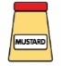 |  |  |  | Jacket Potato  Chicken Mayonnaise |  | Jacket Potato with  Coleslaw (V) |  |  |  | Jacket Potato  Cheese (V)
Sandwich Selection
A selection of sandwiches with various fillings is available daily. Please see separate sandwich menu for Allergen information.
Dessert Choice |  |  | Dessert Choice |  |  |  | Dessert Choice |  | Dessert Choice |  |  |  | Dessert Choice
Fruit  Muffins |  |  | Lemon Drizzle  Cake |  |  |  | Carrot Cake with C/Cheese Frosting |  | Apple Crumble |  |  |  | Frozen  Yoghurts
A selection of Yoghurt Fresh Fruit and Bread is available on a daily basis. Custard is served with desserts as appropriate.
A selection of Mineral Water, Fruit Juice based drinks & Flavoured Milk is available on a daily basis.
Greenwood Academies Trust understands that there are different types of vegetarian diet. Our menus reflect choices available for Lacto-ovo-vegetarians as this is the most common type of vegetarian diet.
All menu items are subject to availability.
Allergen Symbols Key |  | Gluten |  | Milk |  | Eggs |  | Sulphites |  | Mustard |  | Peanuts |  | Soya
 |  | Fish |  | 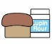Lupin |  | 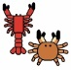Crustaceans |  | Molluscs |  | Nuts |  | Sesame Oil |  | Celery

