Maths Calculation Booklet

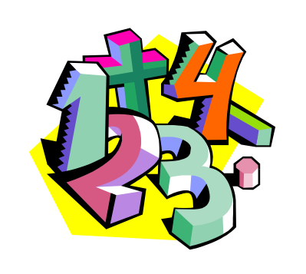

Addition

A. 1. The tWo faces of addition

Children learn that addition can be thought of as combining two sets
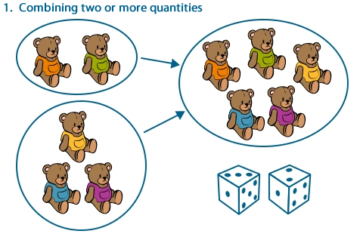
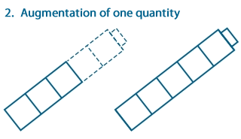

They begin to use resources to combine sets and add to existing sets.
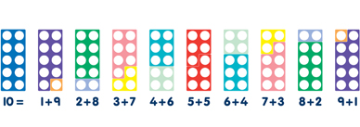

A. 2. The Number line

Children learn that addition in either form can be thought of as “counting on” along a number line.

3 + 2 = 5
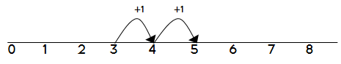

Children then add by counting up in ones, along their number line

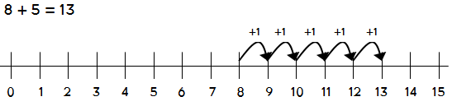

Bead strings or bead bars can be used to help with going past ten.

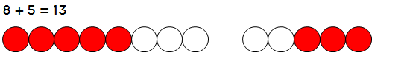

A. 3. The Blank Number line

Children will begin to use blank number lines themselves, starting with the bigger number and counting on.

First counting on in tens and ones.
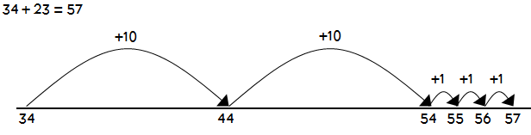
Then, they can start making some jumps all at once, like this:
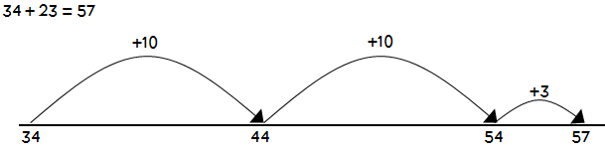

And with the tens too:

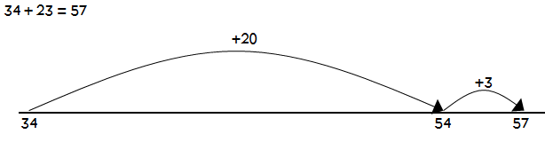

This leads to mental addition of two-digit numbers.

A. 4. Bridging 100

Number lines are used for bigger and bigger numbers. Make sure we count from the biggest number, it makes things quicker. Introduce splitting to make mental calculation easier.

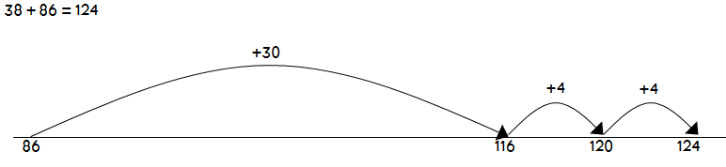
Counting on, and then back (this is a really useful trick)

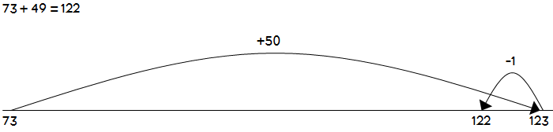

A. 5. Towards a Written Method - Partitioning

Children will have learned to “partition” numbers. This means splitting them up, like this:
351 + 237 = 588. This is then used to add two numbers together. Dienes apparatus and compact place-value counters are first used in this step.

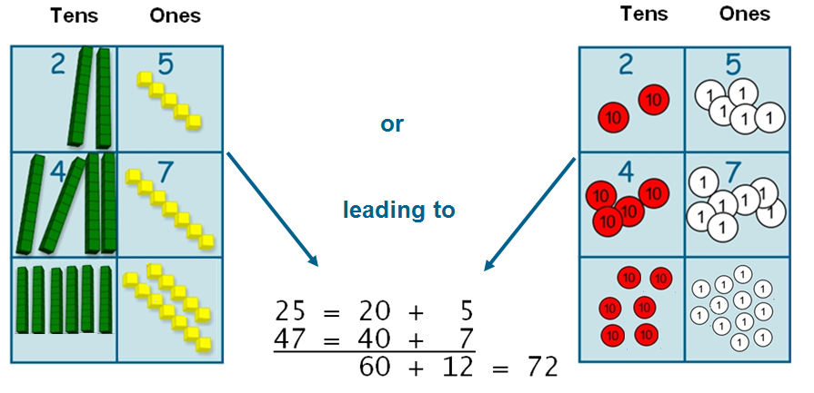

The method is the same where bridging 100 or 1000 is required.

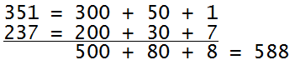

And then harder ones, like this:
1675 + 288 = 673

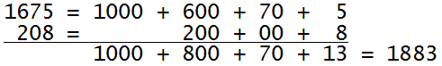
Note: A child at this point in his or her steps to understanding addition would be expected to know that a mental method would have been quicker for the last example.

A. 6. Increased efficiency - Column Addition

They will then learn to add up the bits of the number, without partitioning first. We call this column addition.

25 + 47 = 72
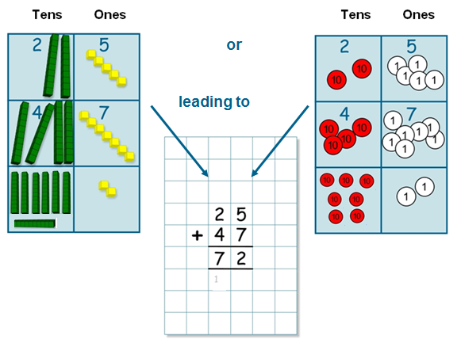
1

From this, children will begin to carry ‘spare’ digits below the line.

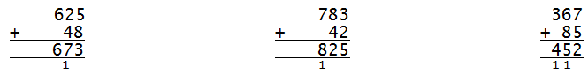

A. 7. Larger numbers

When a mental method in not appropriate, this method is the most efficient method of adding numbers, of any size, including decimals.

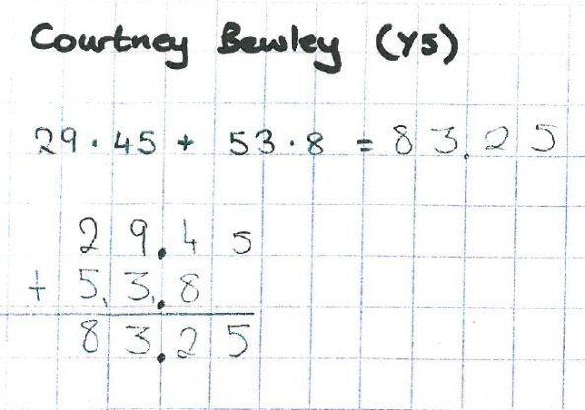
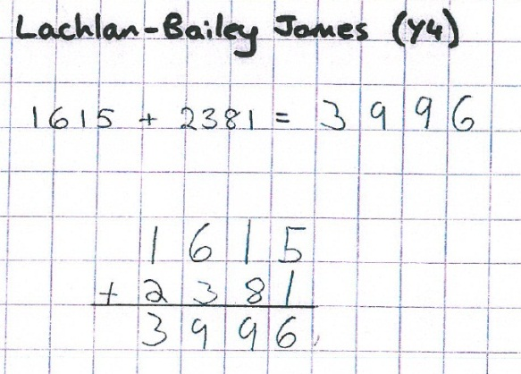
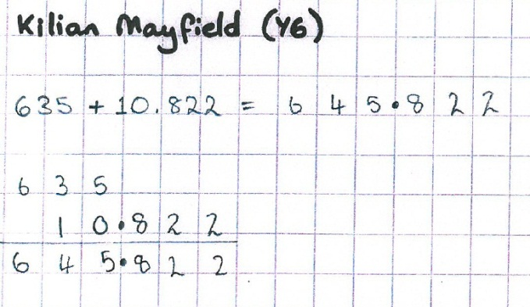

Subtraction

S. 1. The Three Faces of Subtraction

Children learn about taking items away from a set, comparing two sets or splitting a set.
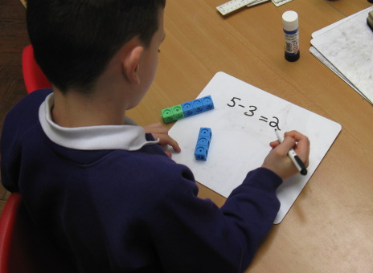
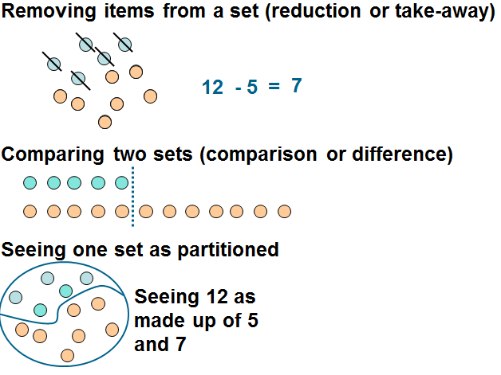
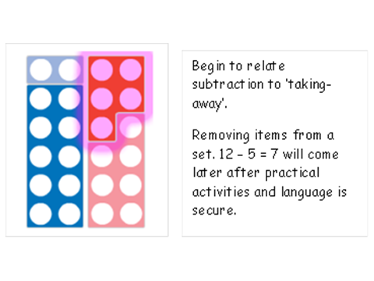

S. 2. The Number Line

They use number lines in conjunction with other and practical resources to support calculation. Teachers demonstrate the use of the number line, and show its use if different ways.

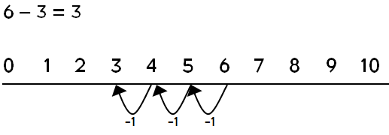
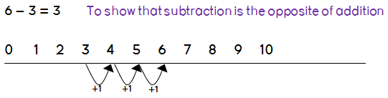
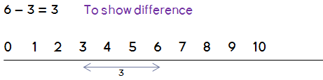

This method uses the number line to show that 6 - 3 means the ‘difference between 6 and 3’ or ‘the difference between 3 and 6’ and how many jumps they are apart.

Children then begin to use numbered lines to support their own calculations - using a numbered line to count back in ones, or count on from the smaller number in ones.

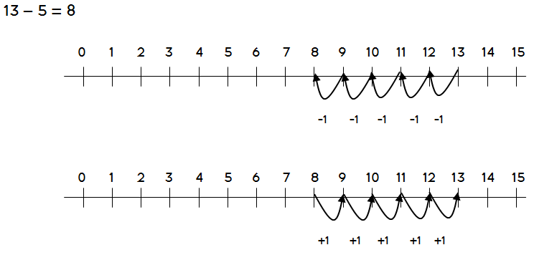

Bead strings or bead bars can be used to illustrate subtraction including bridging through ten by counting back 3 then counting back 2 (see next section).

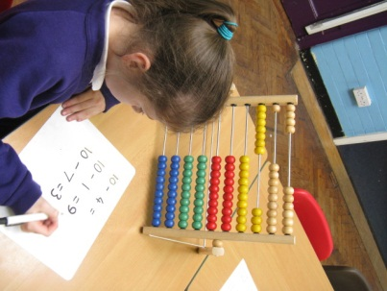
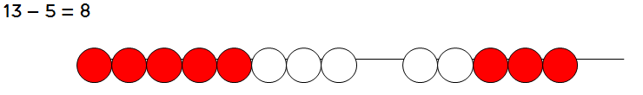

S. 3. The Blank Number Line

From this section forward, it is assumed that as well as counting back, children will learn to count on as an alternative, and be taught whEN to use counting on, and when to use counting back.

Children will begin to use blank number lines to support calculations. First counting back in tens and ones.
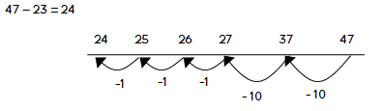
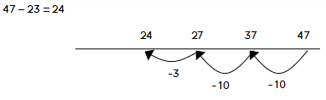
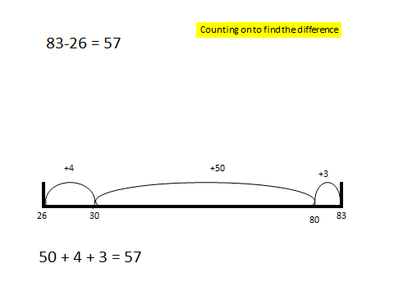

S. 4. Towards a written Method - Partitioning

Initially, the children will be taught using examples that do not need the children to include decompostion.

This method can be demonstrated by the teacher as means of introduction, using manipulatives:
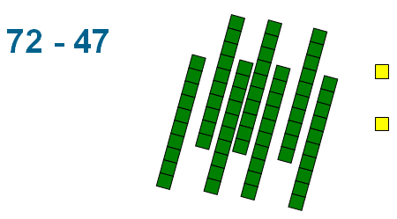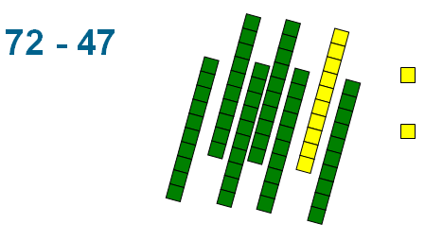
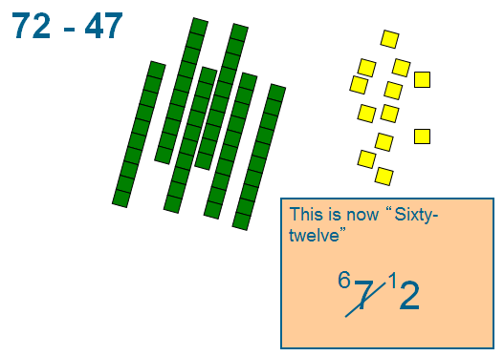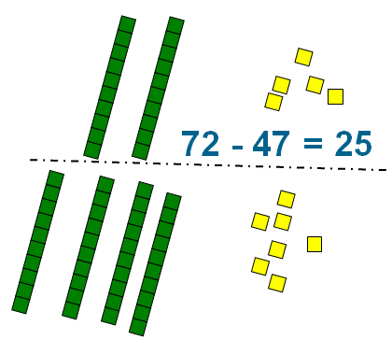
This becomes a written method:

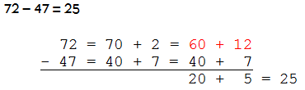

S. 5. Increasing Efficiency – Column Subtraction

Children will learn to carry out this method without the middle step of partitioning. This is the most efficient non-mental method for subtraction:
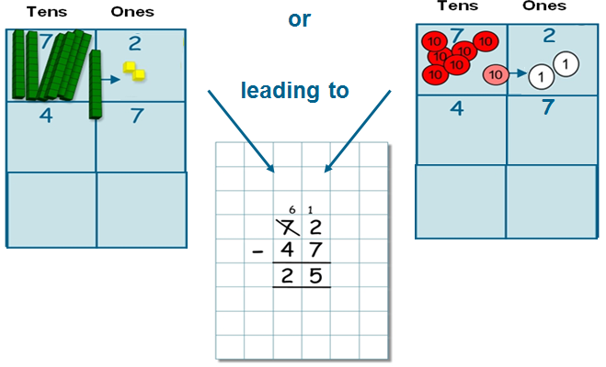
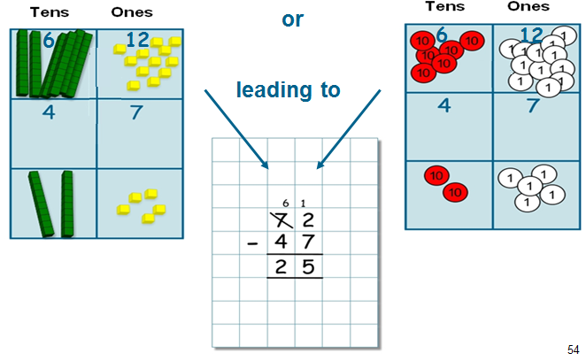

S. 6. Larger numbers and decimals

The method of decomposition can be extended to numbers of any size, including decimals.

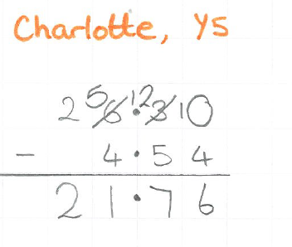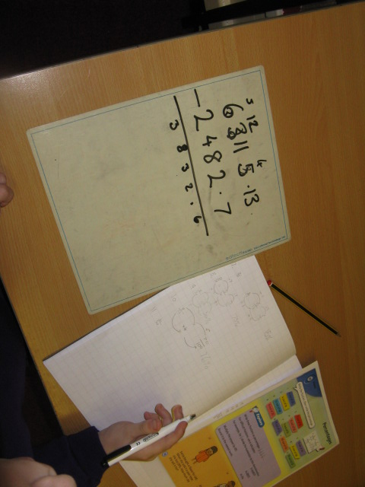

Note: Where the numbers are involved in the calculation are close together or near to multiples of 10, 100 etc counting on using a number line should be used:

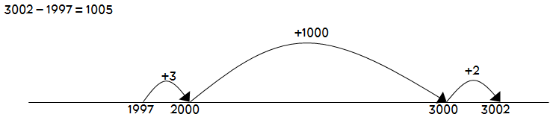

Multiplication

M. 1. What is Multiplication?

Children will begin their work on multiplication by creating copies of the same set, and relating this to repeated addition.
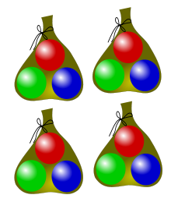
Children will develop their understanding of multiplication and use jottings to support calculation:
Repeated addition is then shown easily on a number line:
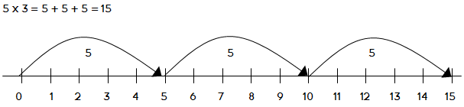

or on a bead bar:
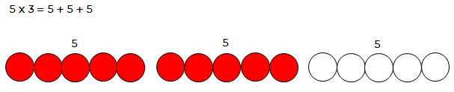

M. 2. Arrays

Children should be able to model a multiplication calculation using an array. This knowledge will support with the development of the grid method.
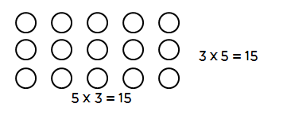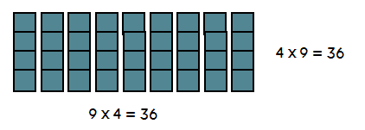

M. 3. Towards a Written Method – Partitioning Arrays

Children will continue to use arrays where appropriate leading into the grid method of multiplication. This leads to partitioned arrays as the first step to learning the grid method for multiplication.
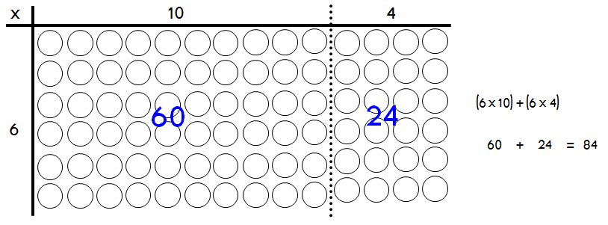
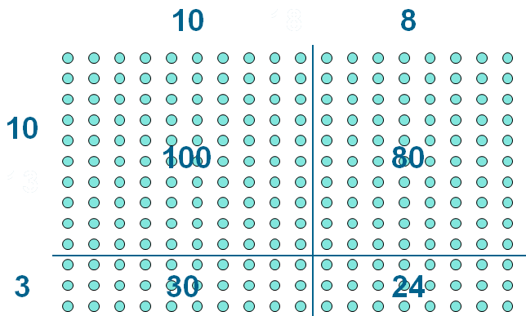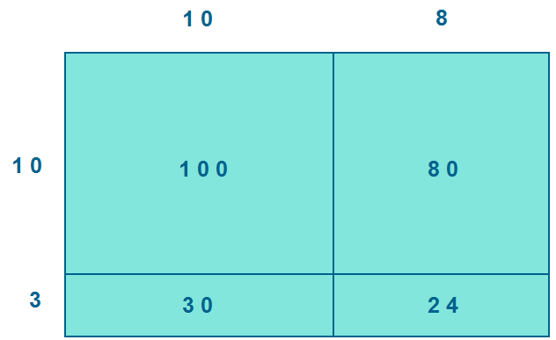

M. 4. WRITTEN METHODS

As shown in the last example, the grid method for multiplication follows from the partitioning of arrays shown in section M. 4.

Children will approximate first, e.g. 23 x 8 is approximately 25 x 8 = 200

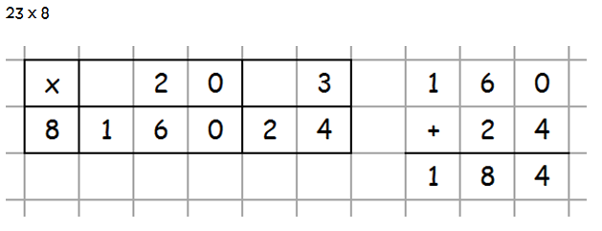
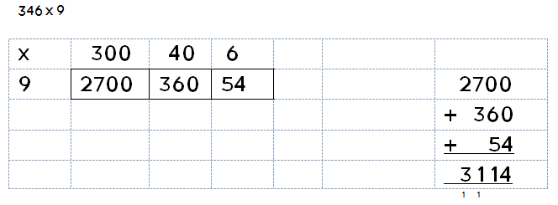
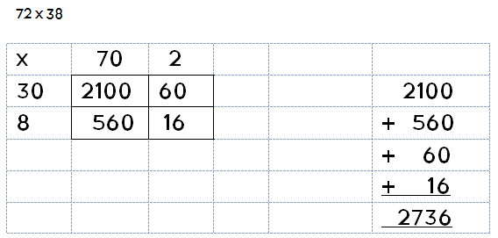
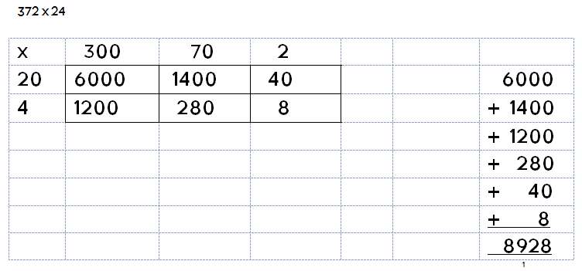

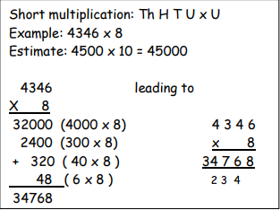
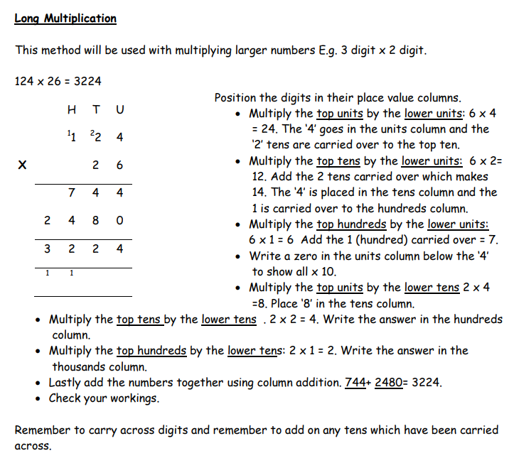

M. 6. Multiplication by decimals

The grid method is used to multiply decimals in the same manner. Mental methods should be used to find the entries in the grid as necessary. Place value counters (available down to 0.01 are particularly useful here).

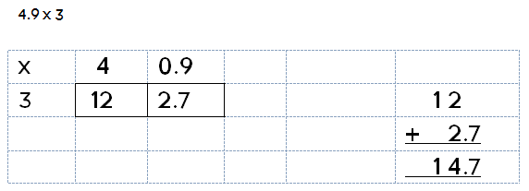
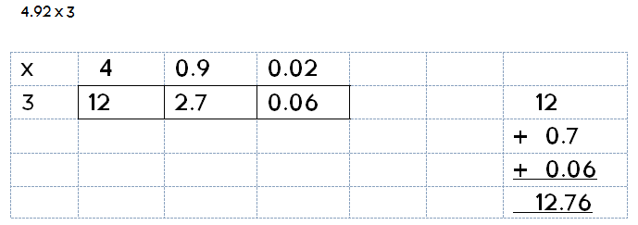
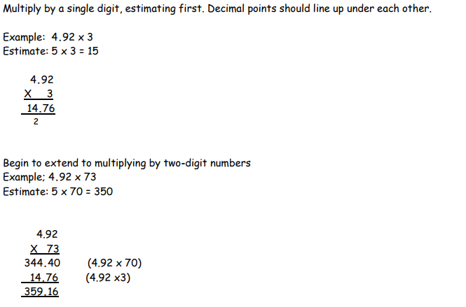
Division

D. 1. What is division?

Children will first learn about division in terms of grouping objects, sharing equally and by repeatedly subtracting:

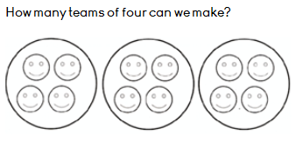
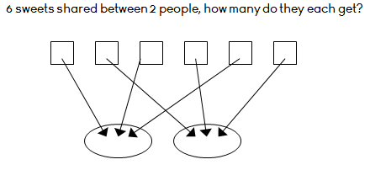
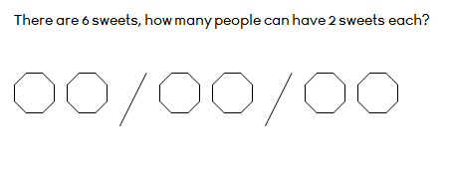

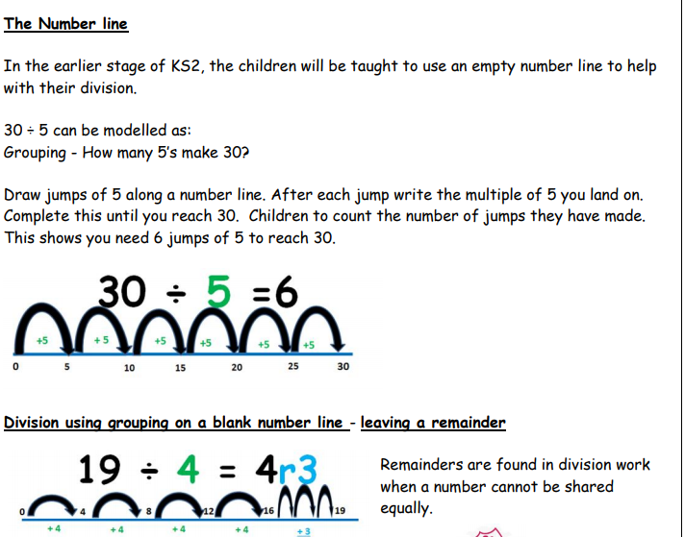

This method is suitable for use with larger divisors as well as smaller ones. Once children understand the written method for repeated subtraction with single-digit divisors, they progress to larger divisors. This can be supported by use of unmarked number-lines. Place value counters are particularly useful here. See video for more information.
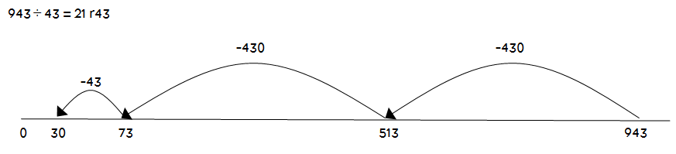
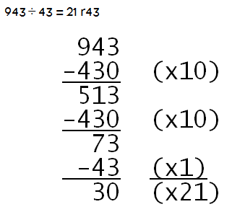

short Division

Dienes apparatus and place-value counters are used to introduce division by grouping after partitioning.
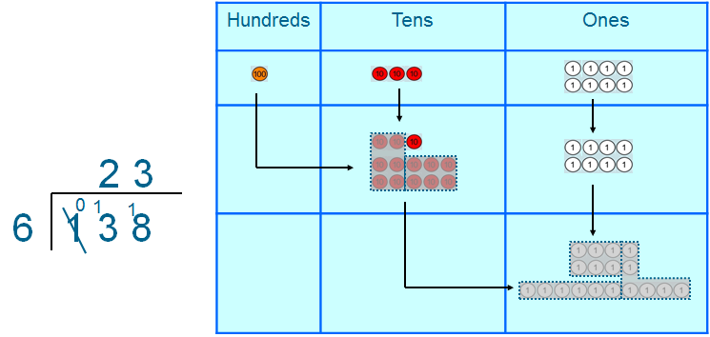
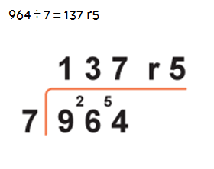

Alternative presentations of the remainder
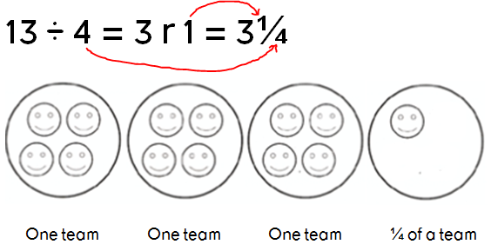
Presentation of the remainder as a decimal can be done either by converting the fraction form above to a decimal, or using the extended short method for division. Place value counters (available down to 0.01) are particularly useful here.
