Monday  Week 1 |  |  | Tuesday  Week 1 |  |  |  | Wednesday  Week 1 |  | Thursday  Week 1 |  |  |  | Friday  Week 1
Main Meal Choice
Chicken & Mushroom Pie  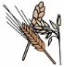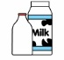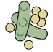  Country Vegetable Mix  New Potatoes  Gravy |  |  | Gammon Steak &  Pineapple Slice  ½ Baked Potato  Whole Green Beans |  |  |  | Roast Turkey  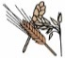  with Stuffing  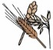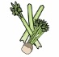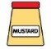  Roast Potatoes, Cabbage,  Carrots and Gravy |  | Meat/Fish Pizza Selection  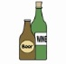  Mixed Salad &  Coleslaw  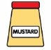  or Baked Beans |  |  |  | Cottage Pie  Broccoli, Sweetcorn,  Gravy
Vegetarian Choice
(V) Bean & Vegetable  New Potatoes, Garden Peas  Gravy |  |  | (V) Vegetarian Sausage  in a Hot Dog Roll  with Mixed Salad |  |  |  | (V) Vegetable Wholemeal Pasta  Crusty Bread  Mixed Salad |  | (V) Vegetarian Pizza Selection  Mixed Salad  Coleslaw  or Baked Beans |  |  |  | (V) Quorn Meatballs with Pasta  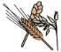  or Rice  & Garlic Bread  Sweetcorn or Mixed Salad
Jacket Potatoes are served with either a mixed salad or a selection of daily vegetables.
Jacket Potato  Cheese (V) |  |  | Jacket Potato  Tuna Mayonnaise  Or Baked Beans |  |  |  | Jacket Potato  Chicken Mayonnaise |  | Jacket Potato  Baked Beans (V) |  |  |  | Jacket Potato  Cheese (V)
Sandwich Selection
A selection of sandwiches with various fillings is available daily. Please see separate sandwich menu for Allergen information.
Dessert Choice |  |  | Dessert Choice |  |  |  | Dessert Choice |  | Dessert Choice |  |  |  | Dessert Choice
Eve’s Pudding |  |  | Strawberry Shortbread |  |  |  | Banana Sponge |  | Marble Sponge |  |  |  | Fruit Jelly (V)
A selection of Yoghurt Fresh Fruit and Bread is available on a daily basis. Custard is served with desserts as appropriate.
A selection of Mineral Water, Fruit Juice based drinks & Flavoured Milk is available on a daily basis.
Greenwood Academies Trust understands that there are different types of vegetarian diet. Our menus reflect choices available for Lacto-ovo-vegetarians as this is the most common type of vegetarian diet.
All menu items are subject to availability.
Allergen Symbols Key |  | Gluten |  | Milk |  | Eggs |  | Sulphites |  | Mustard |  | 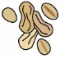 Peanuts |  | Soya
 |  | Fish |  | 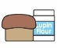 Lupin |  | 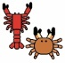 Crustaceans |  | Molluscs |  | 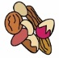 Nuts |  | 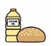 Sesame Oil |  | Celery

