Mansfield Primary Academy Science Curriculum Overview 2024-25
This document covers three distinct areas. Firstly, it outlines the scheme of learning to be taught each term, with headings giving to each of a range of topic areas that ensure the continuity and progression of substantive and disciplinary scientific knowledge.
The second part displays each of the major topic areas and in which year groups these are taught. For each of the major topic areas, you can then see which National Curriculum objectives are covered in that year, together with the term and block in which that objective is first met.
Finally, the third part of this document highlights how disciplinary knowledge (titled working scientifically in the NC) progresses from Year 1 to Year 6. The working scientifically skills have been broken down into eight key areas. Statements that have been taken directly from the NC are highlighted in bold.

Contents
Overviews by Year Group – page 2-3
Knowledge progression by strand – page 5-8
Working Scientifically skills progression by strand – p9-10

Overviews by Year Group
Reception
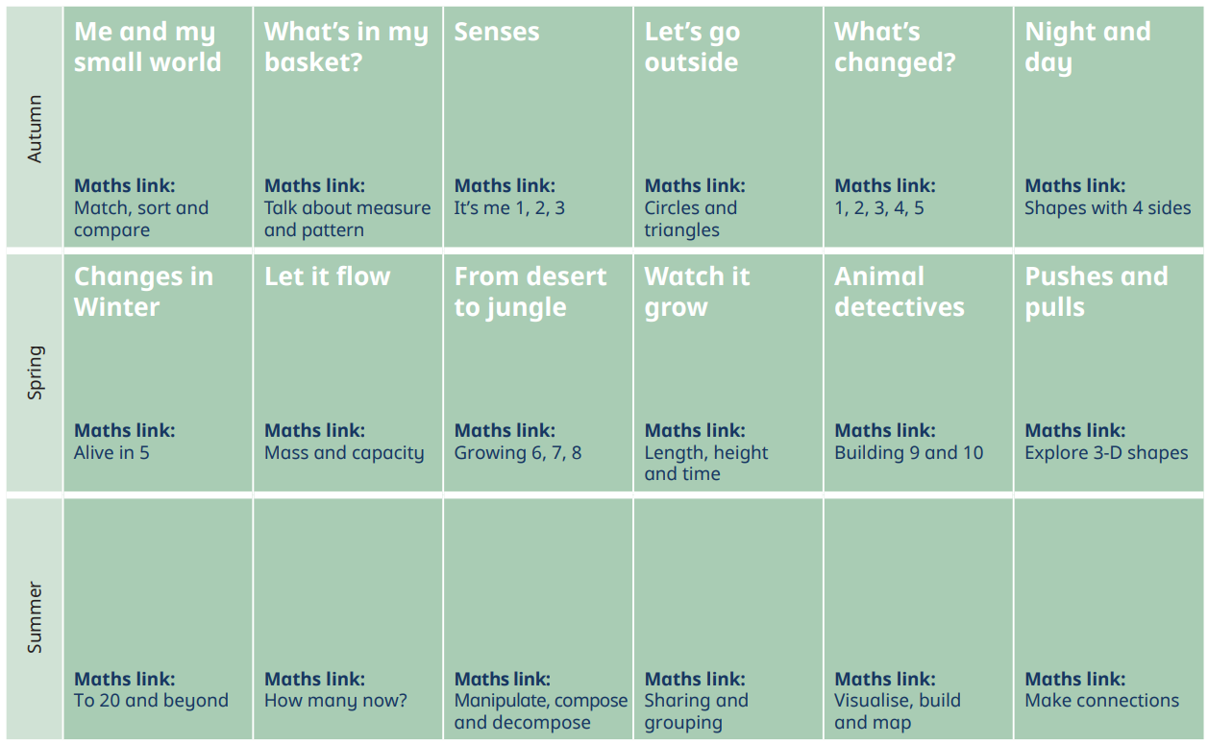
Year 1
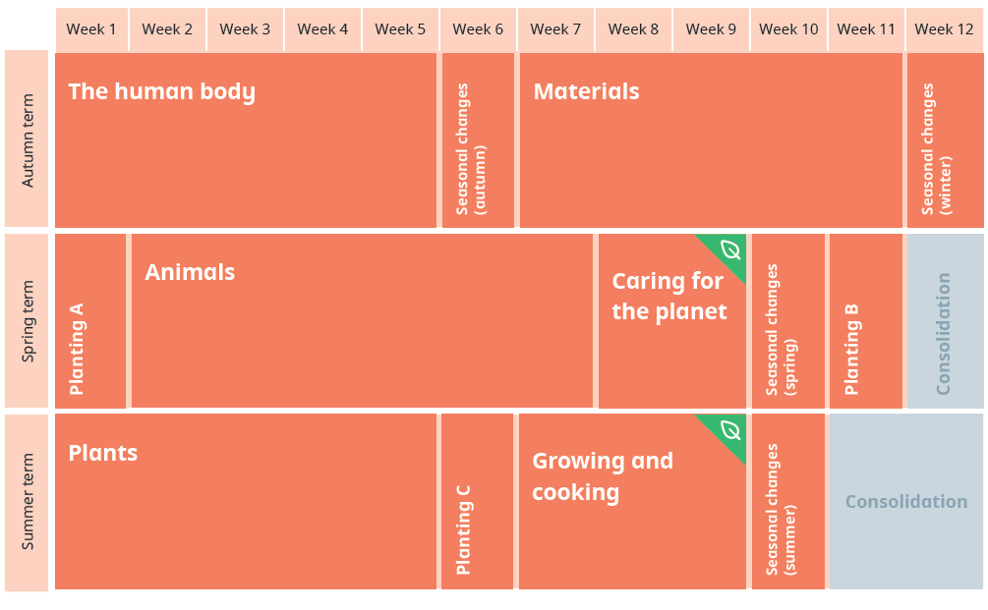
Year 2
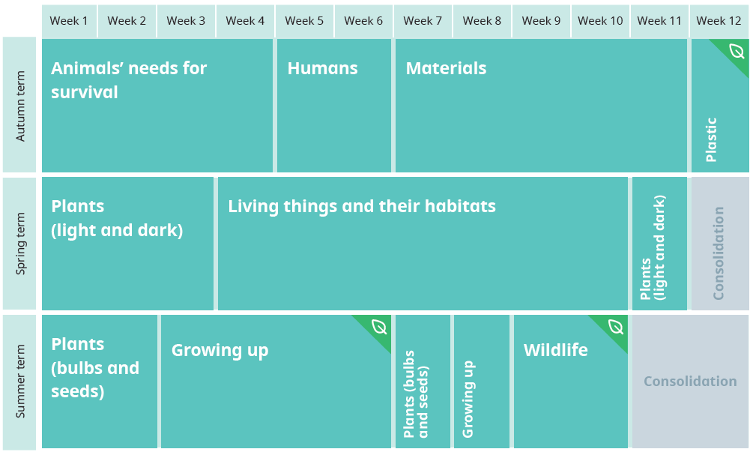

Year 3
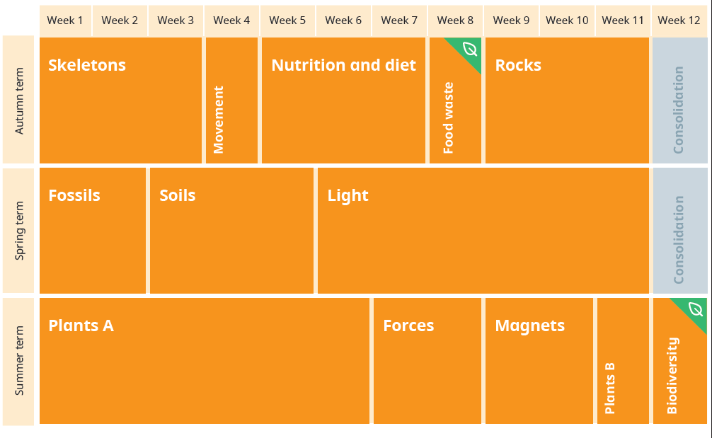
Year 4
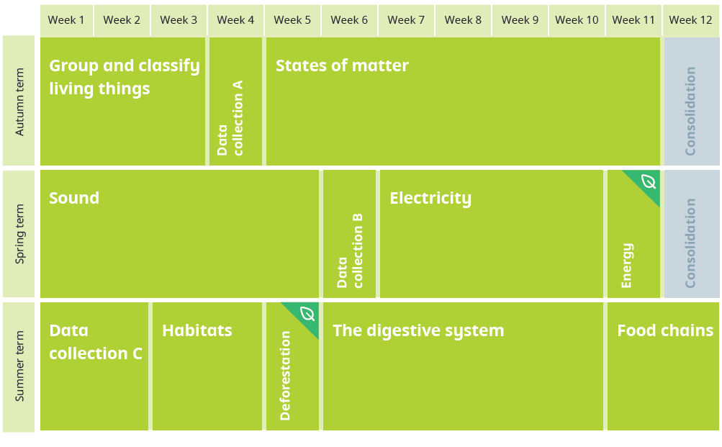
Year 5
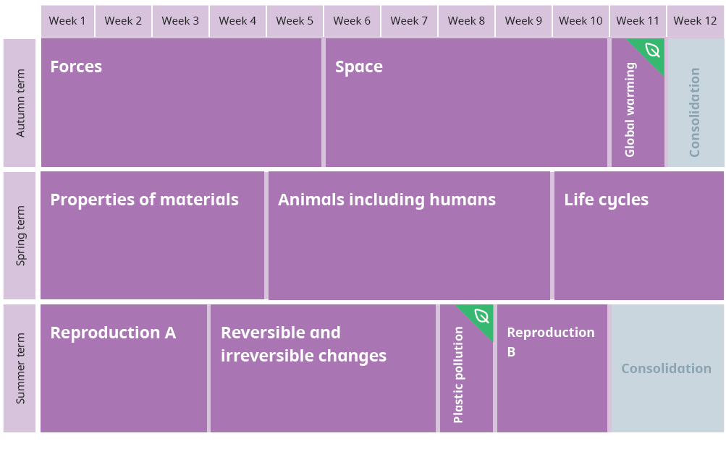

Year 6
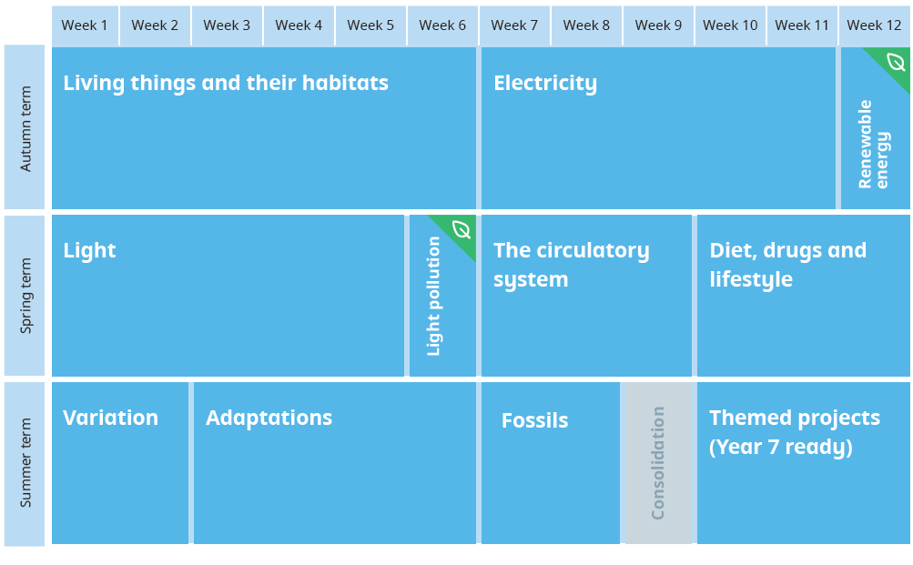

Knowledge progression by strand

Animals including Humans
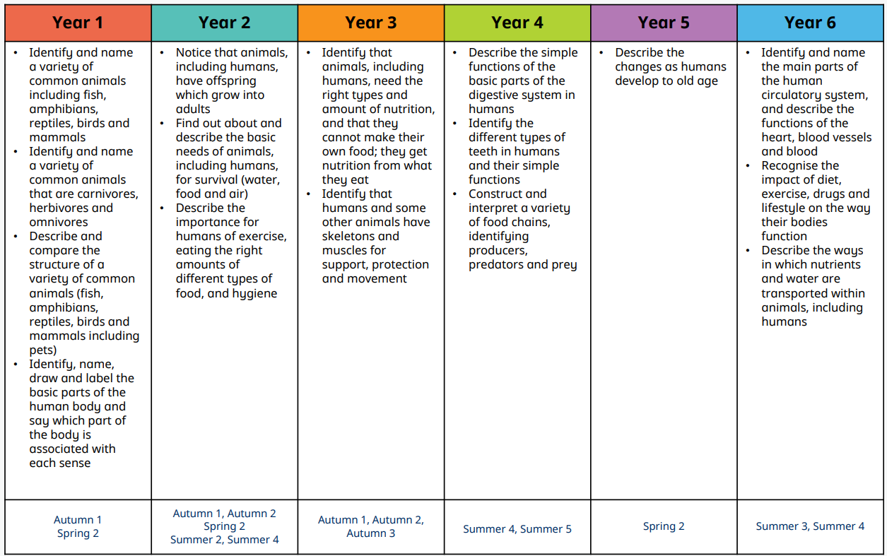
Living Things and their Habitats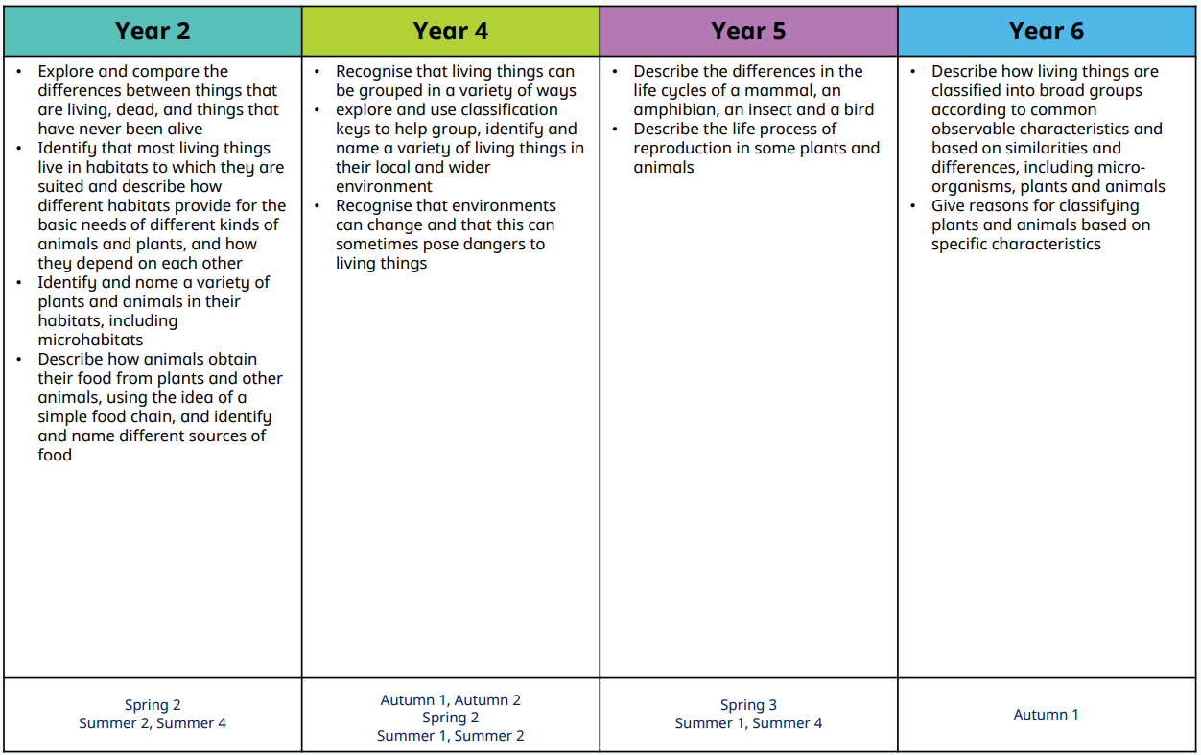
Plants
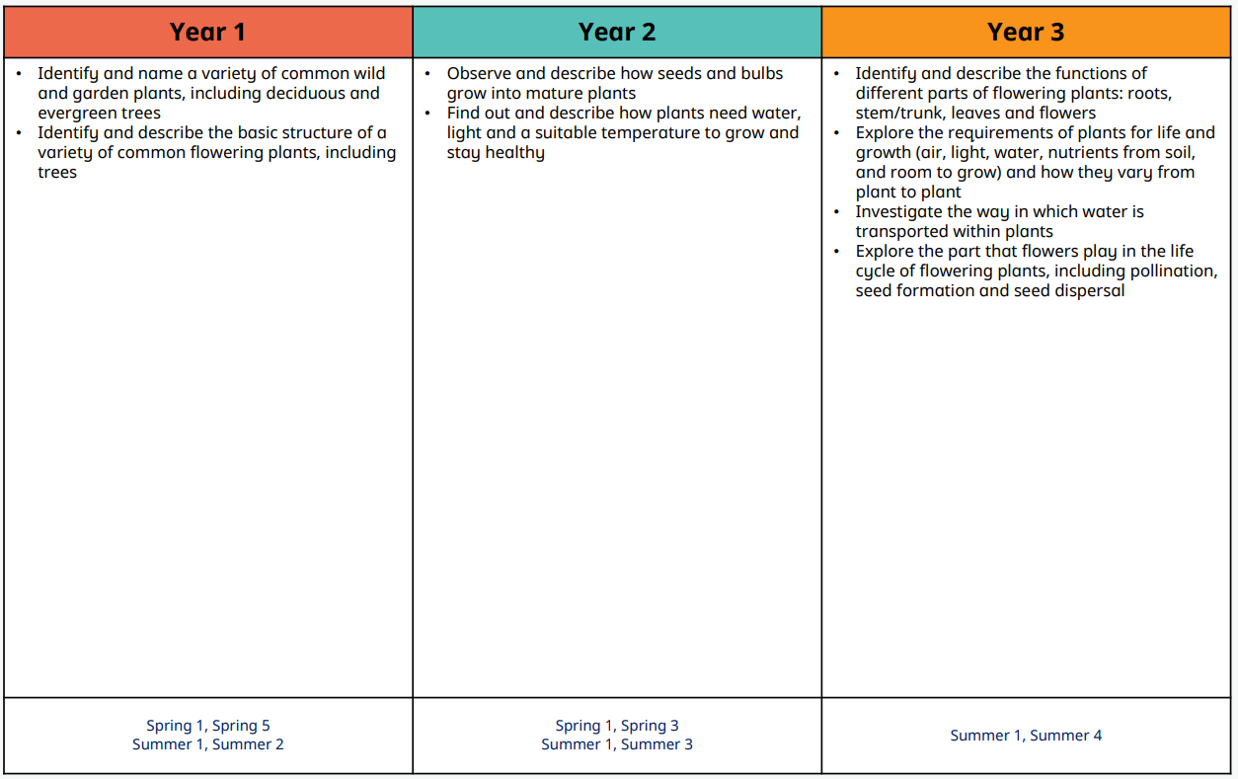

Materials
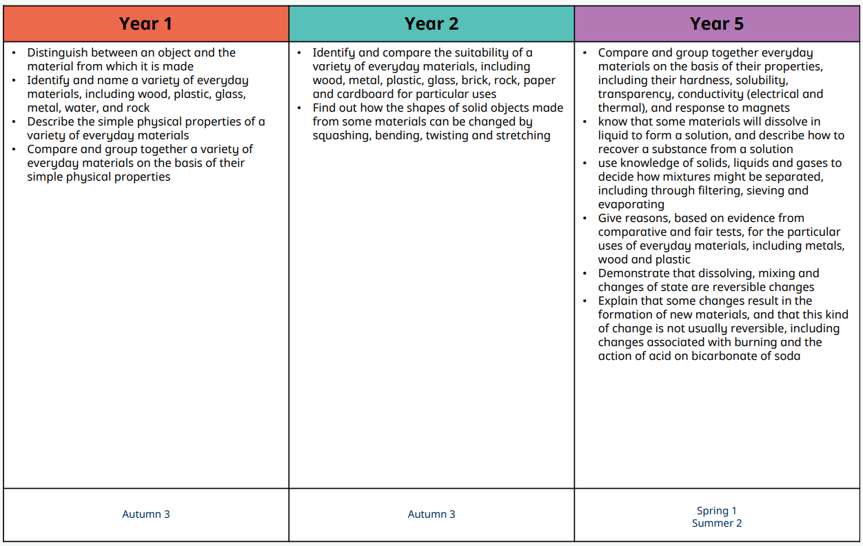
Rocks
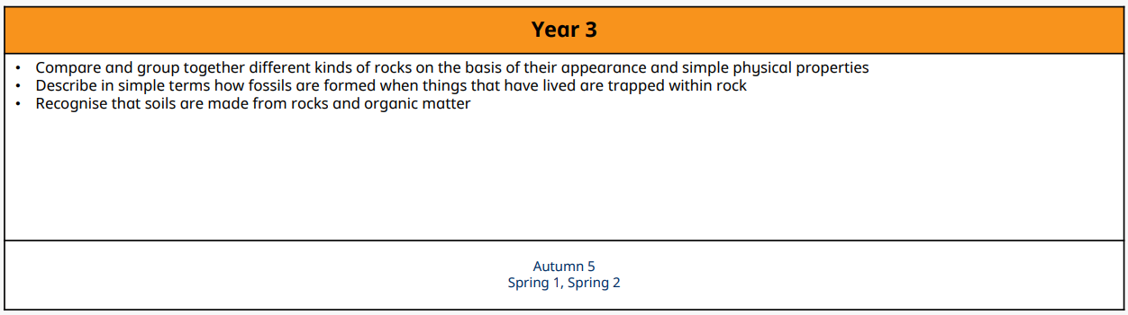
States of Matter
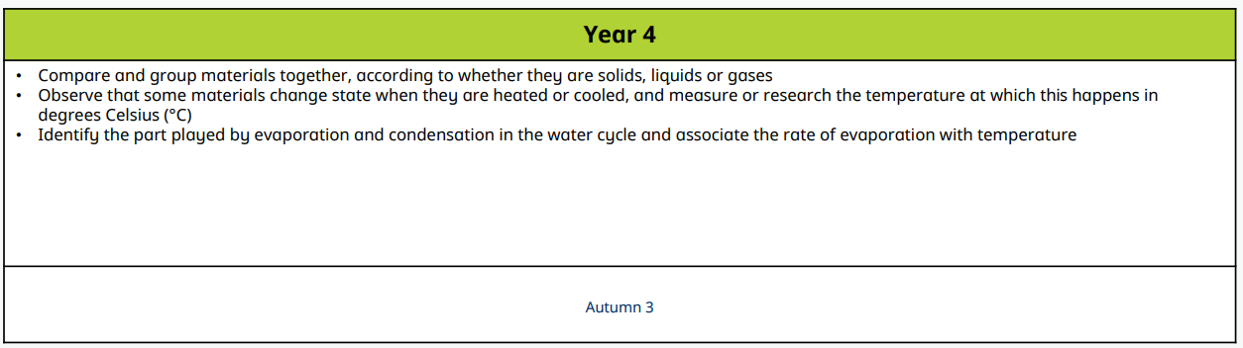
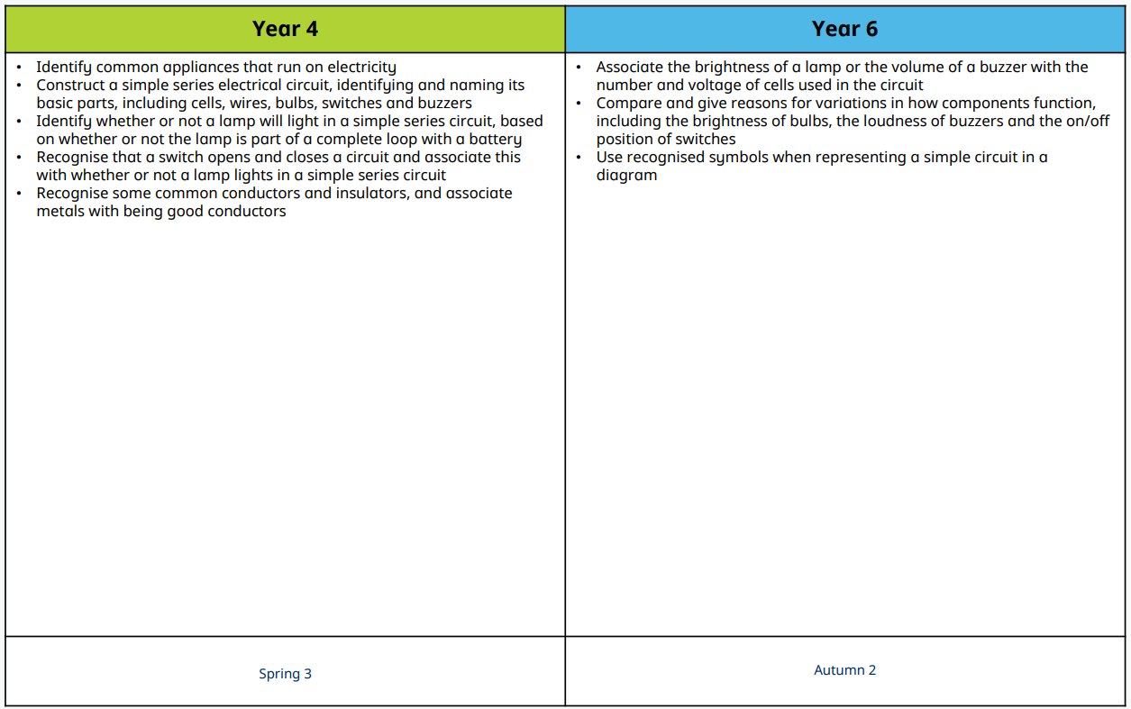
Electricity

Earth and Space
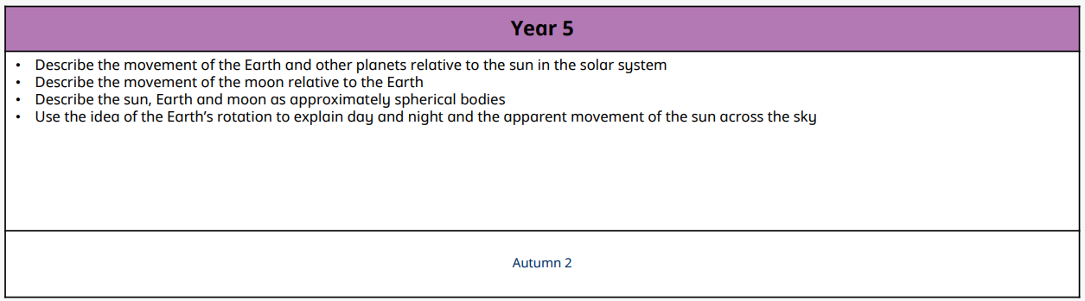
Seasonal Changes
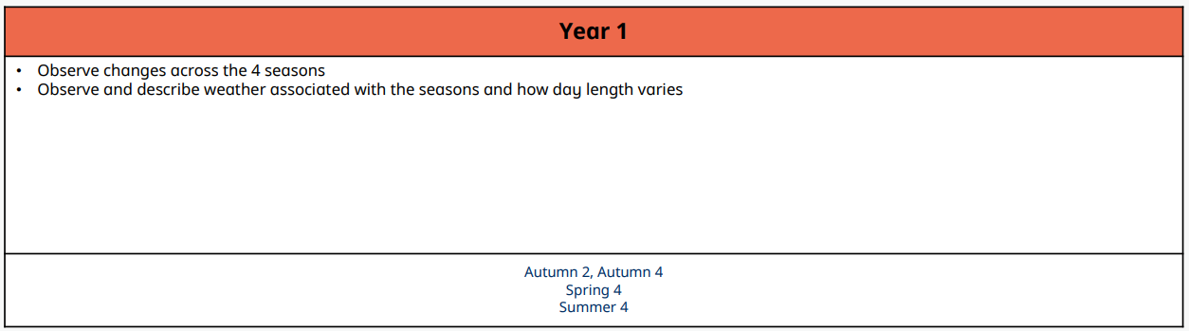
Sound
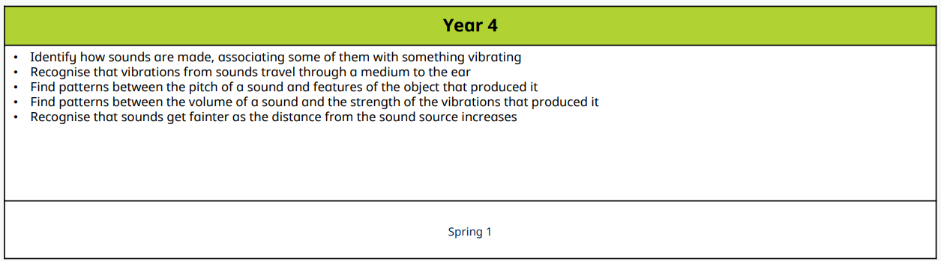
Light
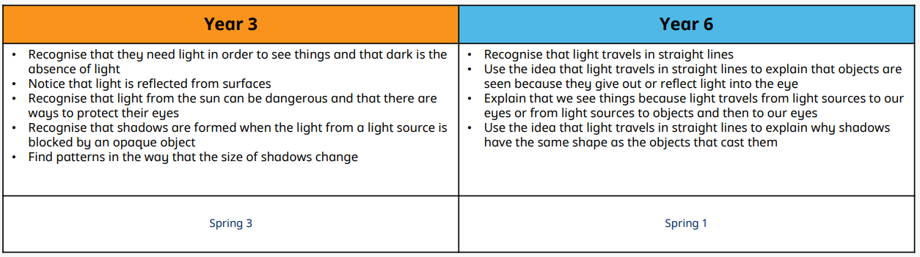
Forces and Magnets
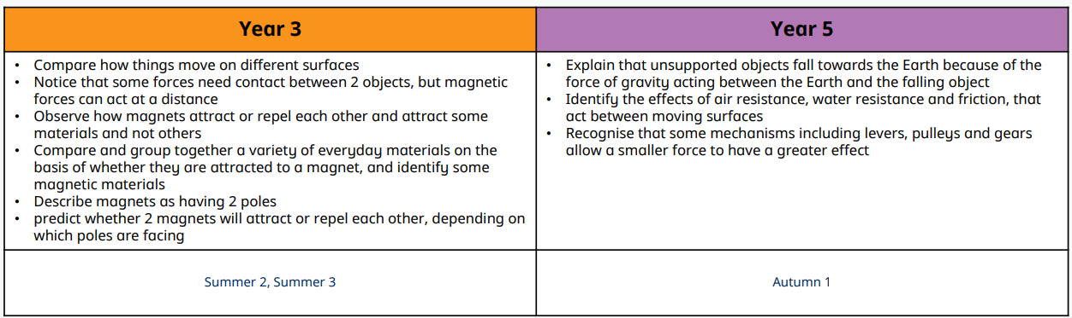

Evolution and Inheritance
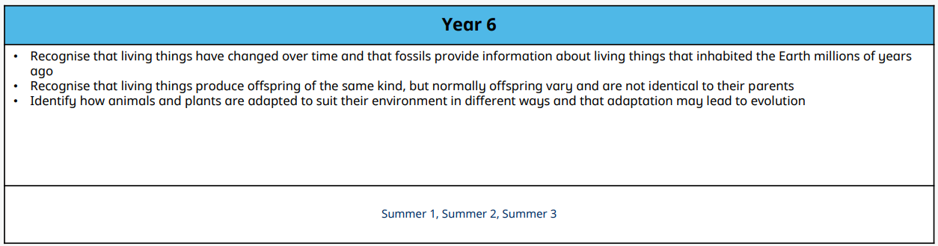

Working Scientifically skills progression by strand
Ask Questions
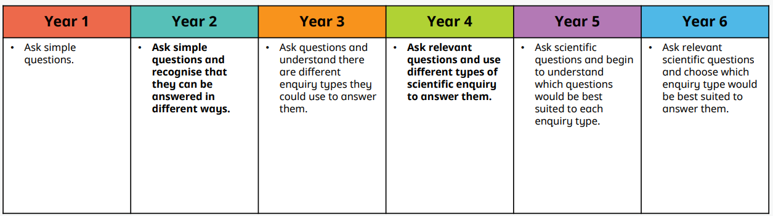
Plan
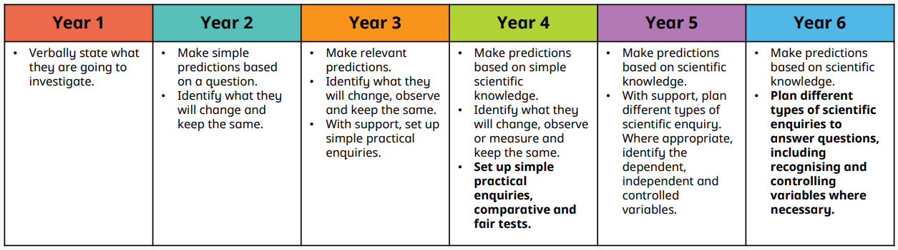
Make Observations
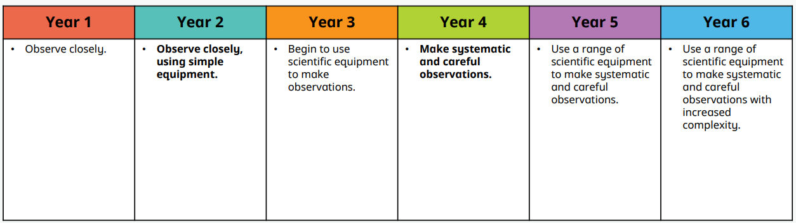
Take Measurements
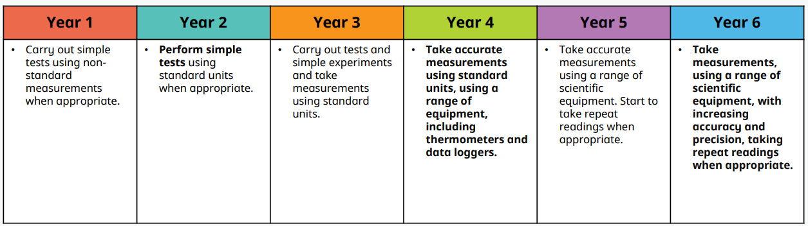
Gather, Record and Classify Data
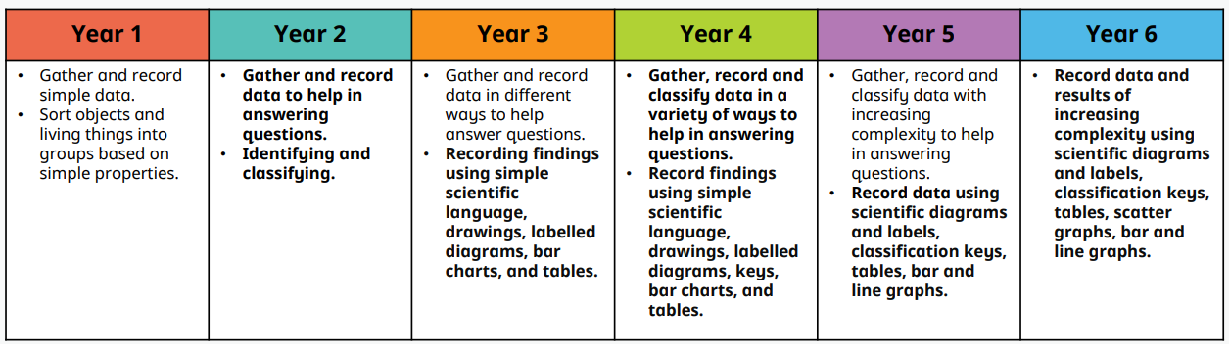
Present Findings
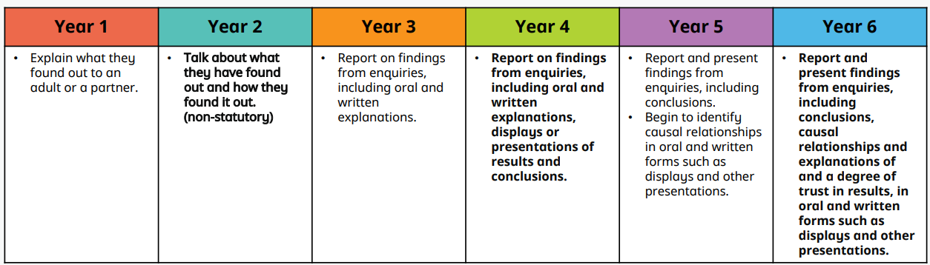
Answer Questions and Make Conclusions
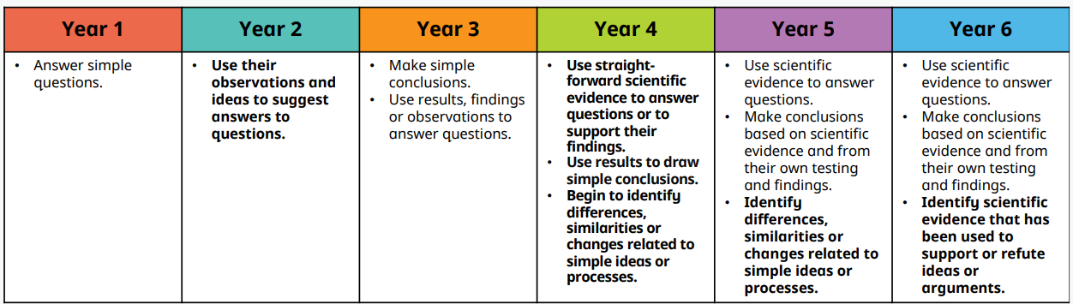
Evaluate


