Mansfield Primary Academy- Computing Curriculum
Throughout Computing at Mansfield Primary Academy, we teach children to stimulate their curiosity through an interactive and practical curriculum.
Term | Autumn 1 | Autumn 2 | Spring 1 | Spring 2 | Summer 1 | Summer 2
Focus | Computing Systems and Networks | Creating Media | Programming A | Data and Information | Creating Media | Programming B
1 | Computing Systems and Networks  Technology, computer, mouse, trackpad, keyboard, screen, click, drag, input, device, shift, full stop, spacebar, capital letter, safety, responsibility.  1.4, 1.5, 1.6 | Creating Media – Digital Painting  Paint program, tool, paintbrush, erase, fill, undo, primary colours, shape tools, line tools, feelings, colour, bush style, Pointillism, prefer, dislike, like.  1.4 | Programming A – Moving a robot  Forwards, backwards, turn, clear, go, commands, instructions, directions, left, right, plan, algorithm, route, program.  1.1, 1.2, 1.3, 1.5 | Data and Information – Grouping Data  Object, label, group, search, image, colour, shape, property, value, data set, less, most, fewest, the same.  1.4, 1.6 | Creating Media – Digital Writing  Word processor, keyboard, keys, letters, Microsoft Word, letters, numbers, space, backspace, text cursor, toolbar, bold, italic, underline, undo, font.  1.4, 1.6 | Programming B – Animations  ScratchJr, Bee-Bot, command, sprite, compare, programming, area, block, joining, start, program, background, delete, reset, algorithm, predict, effect, change, value, block, instructions, appropriate, design.  1.1, 1.2, 1.3, 1.4
2 | Computing Systems and Networks – IT Around Us  Information technology, computer, barcode, scanner/scan.  1.4, 1.5, 1.6 | Creating Media – Digital Photography  Device, camera, photograph, capture, image, digital, landscape, portrait, horizonal, vertical, field of view, narrow, wide, format, framing, focal, paint, matter, flash, focus, background, foreground, editing, filter, pixl, changed, real.  1.4, 1.5, 1.6 | Programming A – Robot Algorithms  Instruction, sequence, clear, unambiguous, algorithm, program, order, commands, prediction, artwork, design, route, mat, debugging.  1.1, 1.2, 1.3, 1.4 | Data and Information – Pictograms  More than, less than, most, least, organise, data, object, tally chart, votes, total, pictogram, enter, compare, count, explain, chart, compare, attribute, group, same, different, most popular, least popular.  1.4, 1.6 | Creating Media – Digital Music  Music, planets, Mars, Venus, war, peace, quiet, loud, feelings, emotions, pattern, rhythm, pulse, Neptune, pitch, tempt, notes, instrument, create, open, edit.  1.4 | Programming B – Programming Quizzes  Sequence, command, program, run, start, predict, blocks, actions, sprite, modify, match, debug, features, evaluate.  1.1, 1.2, 1.3
3 | Computing Systems and Networks – Connecting Computers  Digital device, input, output, process, program, connection, network, network switch, server, wireless access point (WAP)  2.2, 2.4, 2.6 | Creating Media – Stop-Frame Animation  Animation, flip book, stop frame, animation, frame, sequence, image, photograph, setting, character, events, onion skinning, consistency, delete, frame, media, import, transition.  2.6, 2.7 | Programming A – Sequencing Sounds  Scratch, programming, blocks, commands, code, sprite, costume, stage, backdrop, motion, turn, point in direction, go to, glide, event, task, design, code, run the code, order, note, chord, algorithm, bug, debug.  2.1, 2.2, 2.3, 2.6 | Data and Information – Branching Databases  Attribute, value, questions, table, objects, branching, databases, objects, equal, even, separate, order, organise, j2data, selecting, pictogram, information, decision tree, questions.  2.6 | Creating Media – Desktop Publishing  Text, images, advantages, disadvantages, communicate, don’t, style, template, desktop, publishing, copy, paste, layout, purpose, benefits.  2.5, 2.6 | Programming B – Events and Actions in Programs  Motion, event, sprite, algorithm, logic, move, resize, extension block, pen up, set up, design, action, debugging, errors, setup, test.  2.1, 2.2, 2.3, 2.6
4 | Computing Systems and Networks – The Internet  Internet, network, router, network security, network switch, wireless access point (WAP), router, website, web page, web address, routing, route tracing, browser, World Wide Web, content, links, files, use, download, sharing, ownership, permission, accurate, honest, adverts.  2.4, 2.5, 2.6, 2.7 | Creating Media – Audio Production  Audio, record, playback, microphone, speaker, headphones, input, output, start, stop, podcast, save, file, selection, edit, mixing, time shift, export, MP3, evaluate, feedback.  2.5, 2.6, 2.7 | Programming A – Repetition in Shapes  Program turtle, commands, code, snippet, algorithm, design, debug, logo commands, pattern, repeat, repetition, count-controlled, loop, value, decompose, procedure.  2.1, 2.2, 2.3, 2.6 | Data and Information – Data Logging  Data, table (layout), input device, sensor, data logger, logging, data point, interval, analyse, import, export, logged, collection, analyse, review, conclusion.  2.2, 2.6 | Creating Media – Photo Editing  Image, edit, arrange, select, digital, crop, undo, save, search, copyright, composition, save, pixels, rotate, flip, adjustments, effects, colours, hus/saturation, sepia, version, illustrator, clone, recolour, sharpen, brighten, fake, real, composite, background, foreground, retouch, paste, alter, publication, elements, original, font style, border, layer.  2.6, 2.7 | Programming B – Repetition in Games  Scratch, programming, sprite, blocks, code, loop, repeat, value, forever, infinite loop, count-controlled loop, animate, costume, event block, duplicate, modify, debug, refine, evaluate, algorithm.  2.1, 2.2, 2.3
5 | Computing Systems and Networks – Systems and Searching  System, connection, digital, input, process, output, protocol, address, packet, chat, explore, slide desk, reuse, remix, collaboration.  2.1, 2.2, 2.4, 2.6 | Creating Media – Video Production  Video, audio, recording, storyboard, script, soundtrack, dialogue, capture, zoom, storage, digital, tape, AV (audio-visual), videographer, video techniques, pan, tilt, angle, youtuber, content, camera, colour, export, trim/clip, titles, end credits, timeline, transitions, soundtrack, retake/reshoot, special effects, constructive feedback.  2.5, 2.6, 2.7 | Programming A – Selection in Physical Computing  Microcontroller, crumble controller, components, LED, speaker, crocodile clips, connect, battery ox, program, repetition, infinite loop, count-controlled loop, condition, true, false, input, action, selection, motor, switch, algorithm, debug, evaluate.  2.1, 2.2, 2.3, 2.6 | Data and Information – Flat-file Databases  Database, data, information, record, field, sort, order, group, search, criteria, value, graph, chart, axis, compare, filter, presentation.  2.5, 2.6 | Creating Media – MakeCode  Vector, drawing tools, shapes, object, icons, toolbar, move, resize, colour, rotate, duplicate/copy, zoom, select, alignment grid, handles, consistency, modify, layers, front, back, copy, paste, group, ungroup, reuse, improvement, evaluate, alternatives.  2.6 | Programming B – Selection in Quizzes  Selection, condition, true, false, count-controlled loop, outcomes, conditional statement – the linking together of a condition and outcomes, algorithm, program, debug, implement, question, answer, task, outcomes, test, run, setup, share, evaluate, constructive.  2.1, 2.2, 2.3, 2.6
6 | Computing Systems and Networks – Communications and Collaborations  Search, search engine, Google, Bing, Yahoo, DuckDuckGo, refine, index, crawler, bot, optimisation, links, web crawlers, content creator, ranking, communication, internet, public, private, one-way, two-way, one-to-one, one-to-many, SMS, email, WhatsApp, blog, YouTube, Twitter, BBC Newsround.  2.4, 2.6, 2.7 | Creating Media – Web Page Creation  Website, web page, browser, media, Hypertext Markup Language (HTML), layout, header, media, purpose, copyright, fair use, evaluate, preview, device, breadcrumb, trail, navigation, hyperlink, subpage, implication, external link, embed.  2.5, 2.6, 2.7 | Programming A – Variables in Games  Variable, change, name, value, set, design, algorithm, code, task, artwork, program, project, code, test, debug, improve, evaluate, share.  2.1, 2.2, 2.3, 2.6 | Data and Information – Introduction to Spreadsheets  Spreadsheet, data, data heading, data set, cells, columns and rows, data item, format, common attribute, formula, calculation, call reference, sigma, graph, evaluate, results, comparisons, questions, software, tools, data, purpose.  2.6 | Creating Media – 3D Modelling  2D, 3D, 3D objects, 3D space, view, resize, colour, lift, rotate, position, select, duplicate, dimensions, placeholder, hole, group, ungroup, modify, evaluate, improve.  2.6, 2.7 | Programming B – Sensing Movement  Micro-bit, MakeCode, input, process, output, flashing, USB, selection, condition, if… then… else, variable, random, navigation, design, task, step counter, plan, create, code, test, debug.  2.1, 2.2, 2.3, 2.6

EYFS- Early Learning Goal
The early learning goals that previously linked to computing (EYFS technology) have been removed from the Early Years Foundation Stage Framework 2020. There is no mention of the teaching of technology in the education programmes or development matters document either. We understand how important it is that children develop their technology skills and will continue to use a range of technology to support and enhance learning in other areas of the curriculum. For example, the children will continue to use the Bee-Bots when learning about direction and will use Ipads to listen to and watch animated stories, watch videos linked to our topics and play games to develop phonic and number skills.
In foundation stage the children…….
- Have daily access to a range of technology resources such as torches with switches, remote controlled cars, beebots, talking tins, voice-recording toys, as well as class ipads and interactive whiteboards.
- Use a range of technology resources to support learning in other areas of the curriculum.
- Are taught how to use the resources for different purposes eg ipads to watch videos, play games, take photographs and listen to stories.

E-safety objectives are integral to the Computing and PSHE curriculum. From EYFS to Year 6, we present questions at the beginning of each computing lesson from the e-safety units to ensure the messages around e-safety are reinforced throughout the year.
E-Safety – Project Evolve
 | Autumn 1 | Autumn 2 | Spring 1 | Spring 2 | Summer 1 | Summer 2
EYFS | Self-image and identity | Online Relationships | Online Reputation | Online Bullying | Managing Online Information | Health and Wellbeing
1 | Self-image and identity | Online Relationships | Online Reputation | Online Bullying | Privacy and Security | Health and Wellbeing
2 | Self-image and identity | Online Relationships | Online Reputation | Online Bullying | Health and Wellbeing | Privacy and Security
3 | Self-image and identity | Online Relationships | Online Reputation | Online Bullying | Health and Wellbeing | Managing Online Information
4 | Self-image and identity | Online Relationships | Online Reputation | Online Bullying | Health and Wellbeing | Privacy and Security
5 | Self-image and identity | Online Bullying | Managing Online Information | Health and Wellbeing | Privacy and Security | Copyright and Ownership
6 | Self-image and identity | Online Relationships | Online Bullying | Health and Wellbeing | Privacy and Security | Managing Online Information

Progression of Skills
 | Year 1 | Year 2 | Year 3 | Year 4 | Year 5 | Year 6
Online Safety | Taught across the years.
Computing Systems and Networks | Recognising technology in school and using is responsibly. | Identifying IT and how its responsible use improves out world in school and beyond. | Identifying that digital devices have inputs, processes and outputs, and how devices can be connected to make networks. | Recognising the internet as a network of networks including WWW and why we should evaluate content. | Identifying and exploring how information is shared between digital systems. | Recognising how the WWW can be used to communicate and be searched to find information.
Creating Media | Choosing appropriate tools in a program to create art and making comparisons with working non-digitally. | Capturing and changing digital photographs for different purposes. | Capturing and editing digital still images to produce a stop-frame animation that tells and story. | Capturing and editing audio to produce a podcast, ensuring that copyright is considered. | Planning, capturing and editing video to produce a short film. | Designing and creating webpages, giving consideration to copyright, aesthetics and navigation.
Programming A | Writing short algorithms and programs for floor robots and predicting program outcomes. | Creating and debugging programs and using logical reasoning to make predications. | Creating sequences in a block-based programming language to make music. | Using a text-based programming language to explore count-controlled loops when drawing shapes. | Exploring conditions and selection using a programmable microcontroller. | Exploring variables when designing and coding a game.
Data and Information | Exploring object labels, then using them to sort and group objects by properties. | Collecting data in tally charts and using attributes to organise and present data on a computer. | Building and using branching databases to group objects using yes/no questions. | Recognising how and why data is collected over time, before using data loggers to carry out an investigation. | Using database to order data and create charts to answer questions. | Answering questions by using spreadsheets to organise and calculate data. Introduction to spreadsheets answering questions by using spreadsheets to organise and calculate data.
Creating Media | Using a computer to create and format text, before comparing to writing non-digitally. | Using a computer as tool to explore rhythms and melodies, before creating a musical composition. | Creating documents by modifying text, images and page layouts for a specified purpose. | Manipulating digital images and reflecting on the impact of changes and whether the required purpose is fulfilled. | Creating images in a drawing program by using layers and groups of objects. | Planning, developing and evaluating 3D computer models of physical objects.
Programming B | Designing and programming the movement of a character on screen to tell stories. | Designing algorithms and programs that use events to trigger sequences of code to make an interactive quiz. | Writing algorithms and programs that use a range of events to trigger sequences of actions. | Using a block-based programming language to explore count-controlled and infinite loops when creating a game. | Exploring selection in programming to design and code an interactive quiz. | Designing and coding a project that captures inputs from a physical device.

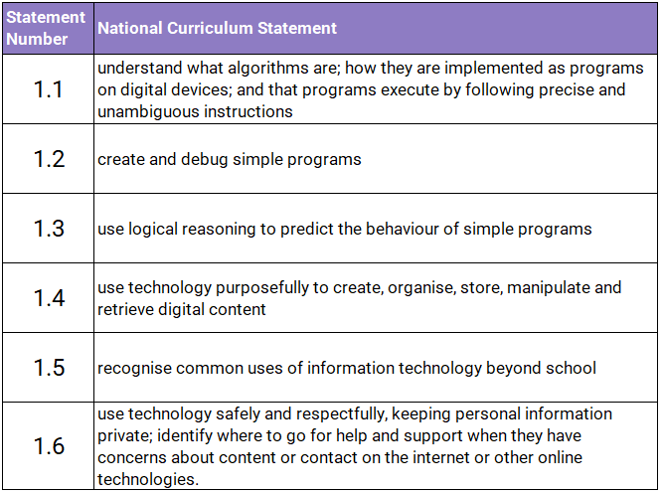
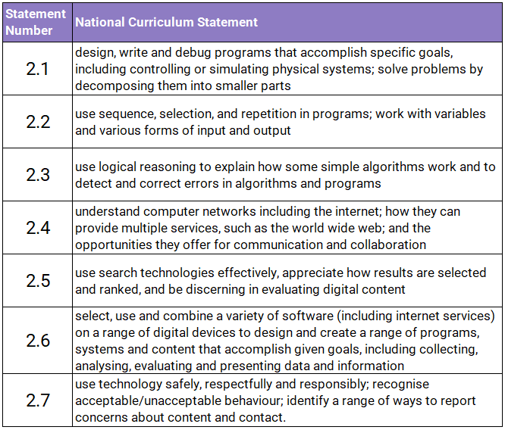
KS1 National Curriculum KS2 National Curriculum

