Home Learning:
On this help-sheet you will find a step-by-step guide to setting up Airhead, Microsoft Teams and Microsoft OneNote, all of which are used to support your child’s learning in school, and at home.
Airhead
To access Airhead, you must:
- Open your internet browser (e.g. Google, Internet Explorer…)
- Search for airhead.io
- At the top right of the screen, you need to select ‘Sign In’. It should be highlighted in green.
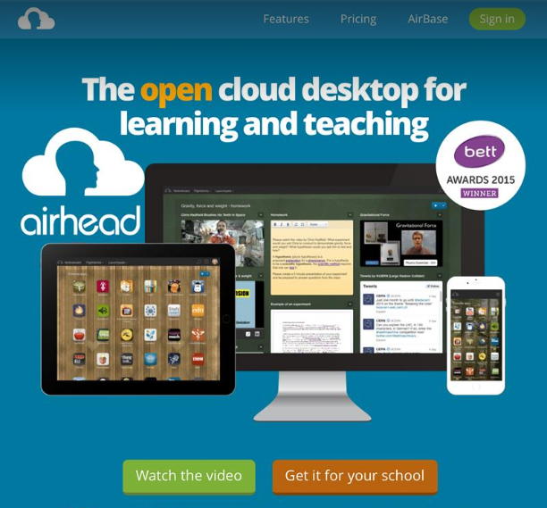

- You will then be taken to a page that asks you to find your establishment. You should type ‘Mansfield Primary Academy’ and then select our school.
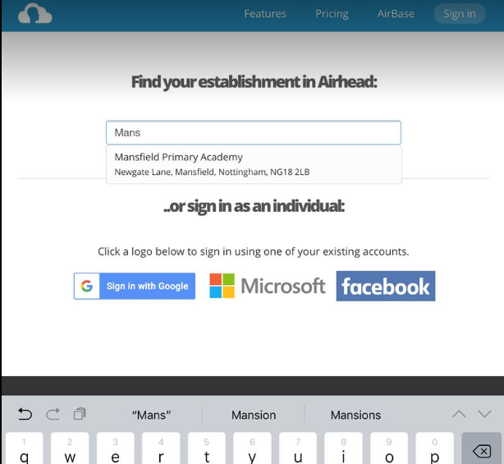

- The next page will ask you to enter your child’s email address. This will have been sent by your child’s class teacher in advance. For reference, if your name is Jennifer Peters and you started at MPA in 2013, the email address would look like this: petej13.64@mansfieldprimaryacademy.org the blue part of the email address is the same for ALL pupils.


- You will now be asked for your password, again the class teacher will supply you with this. It is a good idea to write down your email address and password as soon as you are given them.
- You may then be asked to enter both your email and password together on the same page. If so, simply enter them again.
- You will then be asked if you want to ‘Stay Signed in’. It is recommended to select ‘Yes’ for a smoother experience.
ONCE YOU HAVE FOLLOWED THE ABOVE STEPS ONCE, YOU WILL NOT HAVE TO FOLLOW THEM AGAIN AS YOU WILL REMAIN LOGGED IN.

- You will now be logged in to Airhead. Please select ‘Launchpads’ at the top of the page.
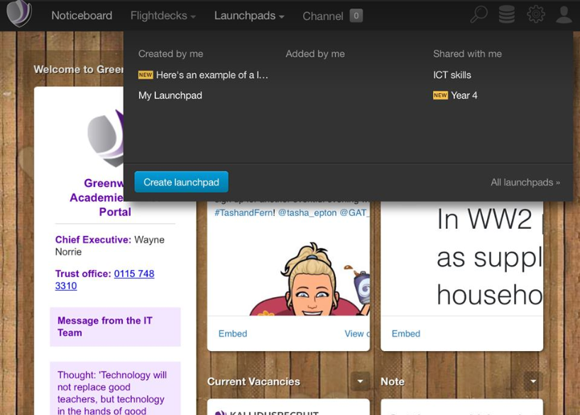

- Under the ‘Shared with me’ tab, you will see launchpads relevant to your child’s year group. Please select one of them. You will then see a screen with different tiles on. Two of which will be Microsoft Teams and Microsoft OneNote.
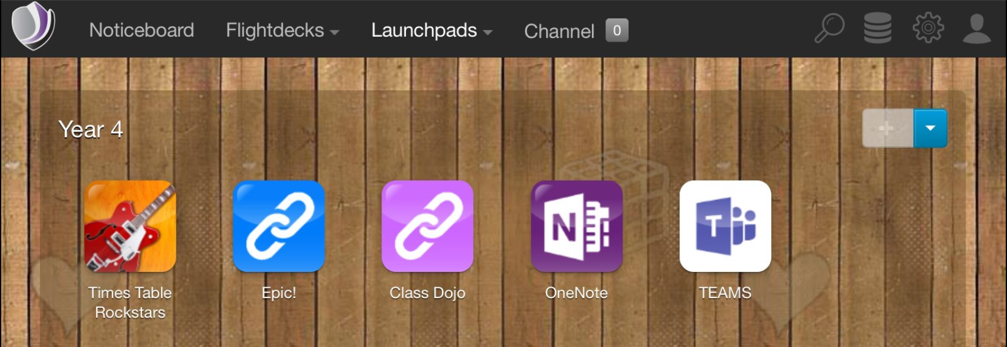
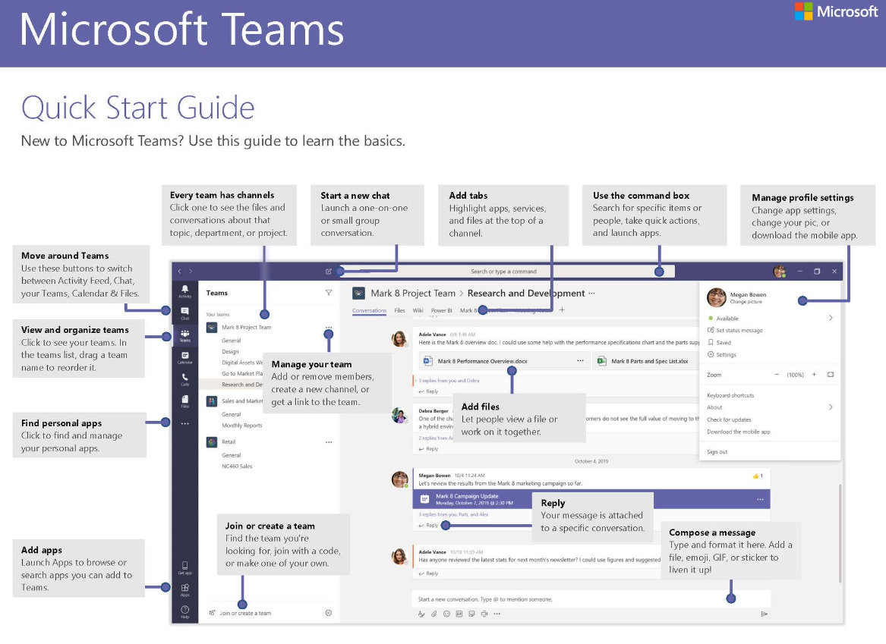
Microsoft Teams:

Microsoft OneNote
- From Airhead, select ‘OneNote’.
- Click the tab that says ‘Shared with me’, then select the notebook that has the name of your child’s class in.
- On the left-hand side of the page, select the three lines to open up a menu. Here, you will see folders titled: ‘Collaboration Space’ and ‘Content Library’. All work set will be in the content library under the relevant day.
- To complete set work, go onto the content library and find the subject you have been set. Right click the task and select copy. Paste the task into your own area and begin working.
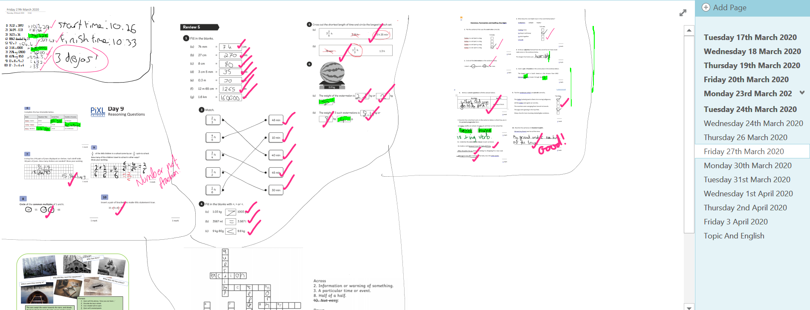
- Your own page may look like this once you’ve copied across the work you’ve been set. Be sure to check back in and see if you got the answers correct, your teacher will try and mark your work as soon as possible.
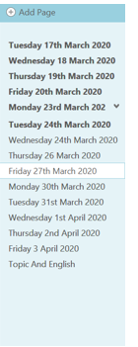
- Remember to make a new page by pressing ‘add page’ when you complete work on a new day.

