A Parent's Guide to AR
What is Accelerated Reader (AR)?
AR is a computer program that helps teachers manage and monitor children’s independent reading practice. Your child picks a book at his/her own level and reads it at his/her own pace. When finished, your child takes a short quiz on the computer
Passing the quiz is an indication that your child has understood what has been read.
Teachers may assist pupils by:
- Guiding them to books appropriate to their ability and interests
- Asking probing questions as your child reads and before quizzing
- Pairing your child with others, reading with or reading to your child
Since they are reading books at their own reading and interest levels, most children are likely to be successful and enjoy the books and quizzes. Best of all they learn and grow at their own pace.
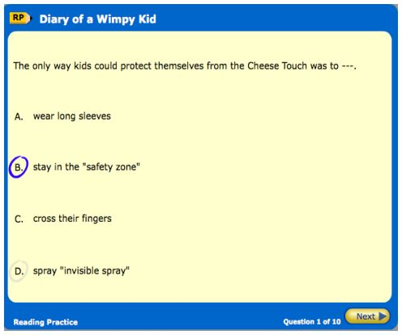
How can I help my child become a better reader?
As with anything, performance improves with practice. According to Renaissance Learning’s research, children who read at least 20 minutes a day with a 90% comprehension rate on AR quizzes see the greatest gains. Encourage your child to read at home, discuss books, ask questions about what they have read and visit your local library.
What is a STAR Reading test?
STAR Reading is used to determine your child’s reading level. It is a computer based reading assessment program that uses computer- adaptive technology. Questions continually adjust to your child’s responses. If the child’s response is correct, the difficulty level is increased. If the child cannot answer a question or answers incorrectly, the difficulty level is reduced. The test uses multiple-choice questions and takes approximately 10 minutes.
What is a Book Level?
Book Levels are reported using the ATOS™ readability formula and represent the difficulty of the text. The levels range from 0.5–13.5. Books are chosen based on the ZPD range recommended for each pupil by STAR Reading.
What is a Zone of Proximal Development (ZPD)?
ZPD is the range of books that will challenge a child without causing frustration or loss of motivation. Your child will receive a ZPD, or reading range after taking a STAR Reading test. It is important for children to read with a high degree of comprehension and within his/her ZPD.
What are points?
Every book that has an AR Reading Practice Quiz is given a points value. AR points are based on the length of the book (number of words). Pupils earn a percentage of points according to how well they pass the quiz.
What is Interest Level?
The Interest level indicates for which age group a book is appropriate, based on the content and themes. These are recommendations only and teachers and parents are recommended to use their best judgement when guiding pupils.
Interest Level | Age
LY - Lower Years | 5 - 8
MY - Middle Years | 9 -13
UY - Upper Years | 14+
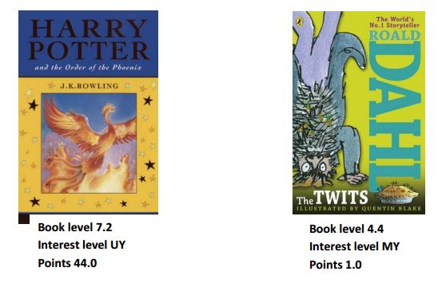
You will notice that the number of points assigned to the books varies according to their length and the amount of reading time required. For example, J K Rowling's Harry Potter and the Order of the Phoenix is worth 44 points while Roald Dahl's The Twits is worth one point.
How can I find further information?
Visit AR BookFinder at www.arbookfind.co.uk to conduct a search of all available books with AR quizzes.

