Mansfield Primary Academy
The use of technology is to support learning
Code of Conduct when using Office 365 applications
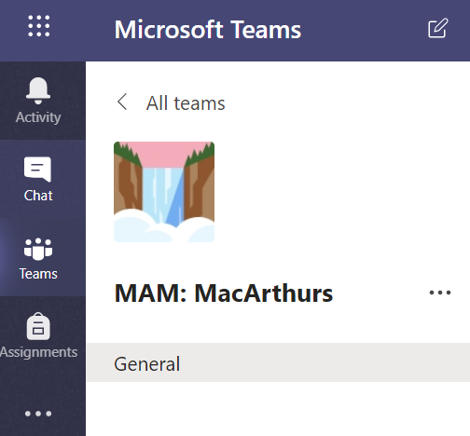
Microsoft Teams
- Pupils may not use Chat or video call at any time – in or out of school
- Teams – Pupils should use Teams to interact with their teacher and classmates. Each class Team has a ‘General’ channel for any talk linked to general learning. They may also have some specific channels linked to certain topics.
- Pupils may respond to comments in their class Team out of school hours. All comments must be linked to learning.
- Pupils may use emoji’s but should aim to write in proper sentences not text speak.

Airhead
- Pupils may access airhead out of school at any time.
- Pupils may not create their own launchpads without their teacher’s permission.
- Pupils may add apps to their launch pad as long as they support learning.
- Pupils may not add social media apps to their launch pads.
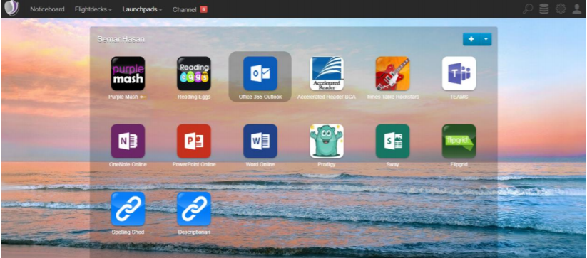

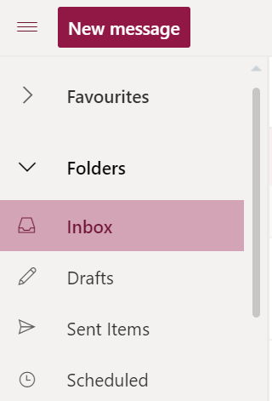
Emails
Like Teams, email accounts may only be used for learning. Use of emails should be kept to the minimum.
Pupils should make a regular habit of reading and deleting emails that are not relevant. Inboxes should be emptied regularly.
Pupils may not email other pupils or adults unless instructed to do so by their teacher.

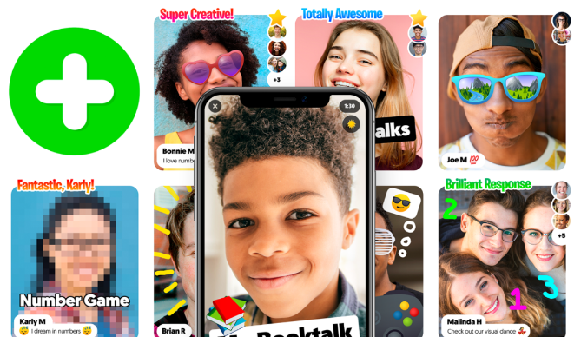
Flipgrid
Pupils may only use Flipgrid if their parents have given written consent.
Pupils may use the emoji’s in their video responses.
Pupils may also like & respond to others pupils posts. Any comments must be positive and appropriate.
Pupils should aim to write in proper sentences not text speak.

Use of Google & other search engines
Pupils may go on other websites during lessons which support learning only.
Pupils may not access sites such as YouTube without permission from their teacher.
Pupils should not attempt to link their own google accounts.
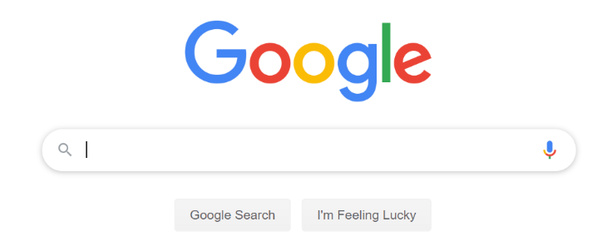
Pupils should not save any websites to their toolbar. Any saved sites should be added to launchpads.

Devices
Pupils should take good care of academy devices. They should not change desktop backgrounds or cursors etc as this will cause devices to run slowly.
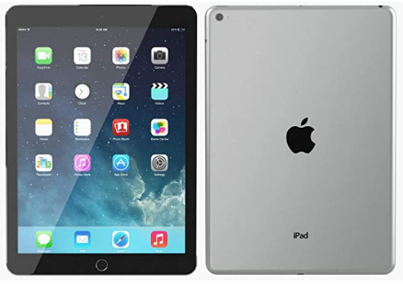
Any pupil not adhering to the Code of Conduct above will have their access to technology restricted or removed.
Any questions please see Mr Derry in Year 6.

