Basic Skills Policy
Mansfield Primary Academy

EYFS expectations

Learning about technology starts from birth because it’s the way the world works today. Technology is an integral part of all young children’s environment and world. They are surrounded by technology just as they are surrounded by language, print and numbers. In the home, technology includes remote controls for television, DVDs and sound systems, toys that have buttons and buzzers, mobile phones, washing machines, microwave ovens and other machines that require programming, and of course, computers and mobile devices such as iPads. Outside the home, children are also immersed in the technological world: they see automatic doors, cash machines, bar code scanners, digital tills and weighing machines, and security cameras. Technology is something children are going to grow up with, learn about and master, and use as a tool to increase their understanding in all areas of learning.

Many activities in the early years revolve around children developing an understanding of their environment. Settings encourage children to explore, observe, solve problems, predict, discuss and consider. ICT resources can provide tools for using these skills as well as being examined, with computers not the only resources. ICT equipment added to role-play reflects the real world, builds on children’s experiences and allows them opportunities to understand how, why, when and where different forms of technology are used in everyday life.
Early experiences form a foundation upon which KS1 and KS2 can build and the current early learning goals have specific objectives relating to ICT. As part of continuous provision and when instructed to use by an adult with supervision or when requested to be used by the child, across a variety of platforms.

Skills across using the IT system:
If asked by a child, adult will supervise the children in logging on and use of apps within airhead – (statement 40-60+ months – completes a simple program on a computer)
Children should be shown how to open the apps within airhead and how to interact with them, and when showing an interest to use this independently should be assisted in logging on.
Children should have access to a variety of IT equipment, tablet, computer, camera, bee bots, tills, talking tins, sound buttons and a variety of real-life equipment such as washing machines and microwaves etc and know the uses of each of them.

Children should be able to experience typing/writing on a computer or touch screen device. Such as on apps like writing repeater within airhead. This also has a simplistic save version - so the children, with adult supervision, can begin to learn to save and open documents.

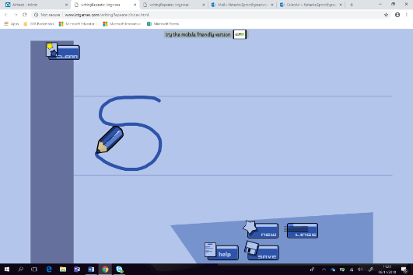

Children should be exposed to a variety of different apps and websites by the time that they leave EYFS and know that different apps will serve different purposes and functions and be able to begin to choose the correct app for the functionality required.
 | Year1 | Year2 | Year 3 | Year 4 | Year 5 | Year 6
Basic Skills | Logging in and out of a computer  Saving in a personal OneDrive  Opening document  Knowing what an email is  Opening email app  Opening a link from email (Forms)  Use a search engine for a purpose  Knowing the safe site - padlock | Begin to choose own name for a document  Understanding what an email is and when to use them  Whole class shared writing of an email – subject box etc | Choose appropriate name for document  Delete document  Writing an email – use of subject and formality of language  Begin touch typing | Changing password when instructed to do so  Appropriately naming documents  Emailing – use of cc, attaching documents, opening and saving documents  Increase speed of touch typing | Creating, changing and recording own passwords  Moving files between folders  Searching emails  Knowing that you can password protect emails  Increase speed of touch typing – to reflect length of work expectation | Using distribution groups for email  Filtering the mail  Protecting emails with a password  Increase speed of touch typing
Core Skills | Printing when appropriate  Typing simple sentences with capital letter and full stop  Inserting image from given shared folder (teacher choice) | Awareness of what is appropriate to print- begin to make this decision  Begin to access the shared class group to open documents | Using print preview to check the look of the document  Beginning to change font/size and layout of the document according to purpose  Use of shift for capital letter and symbols | Knowing the formatting for the selected audience  Images- resizing, formatting, wrapping text | Printing settings – eg double sided | Inserting a hyperlink
Word | Finding keys on a keyboard – space bar/caps lock/full stop  Alternating between upper and lower case  Changing size and colour of the font | Use of return key, backspace, delete  Insert word art  Spell check  Insert online picture using search facility  Change the font  Copy and paste | Use of bullet points  Use of inserting a border  Choosing correct orientation of the page  Insert a text box and format it. | Use of a thesaurus/synonyms  Margins on a page – e.g. smaller for a poster  Inserting columns for newspaper report  Use of shortcuts for copy and paste | Choosing own page design and layout to suit the purpose  Insert header/footer  Insert a table  Highlighting main points | Applying multiple page layouts and designs within one document.  Applying skills previously taught into a project with a purpose  Hyperlinks
Excel | Know the symbol  Put numbers in a cell  Enter a simple chart (linked with tally chart)  Save the document | Open a saved file  Create a tally chart with a title | Add additional sheets/rename them  Basic formula – adding  Wrap the text in a cell  Use of editing bar  Clear fields of information – to read and input  Borders around the cells. | Setting print areas  Knowing how to add a chart and graph  Inserting and deleting columns and rows  Orientation of the text | Reading, interpreting and understanding data  Inputting data  Formula – sum of cells, add/subtract, multiply/divide  Inserting bar and pie charts  Sorting cells – a-z  Formatting cells to 2 decimal places | Advanced formula across sheets  Making scatter graph  Advanced sorting of columns  Formatting number, date etc  Conditional formatting, adding rules for creation of multiplication games
Power Point | Insert text  Insert given pictures  Change the background colour  Insert new slide | Edit a given template – adding pictures and text  Edit the title  Begin to explore slide transitions | Adding correct format of slides  Changing order of slides  Starting a slide show | Basic transitions  Basic animations  Knowing that you need to click space bar for these animations | Creating full presentations with timings  Add notes for presenting  Add audio  Shortcuts, e.g. enter to add a new slide | Create multi-path presentation  Use timings and buttons with hyperlinks  Inserting multimedia, video and audio

